# Chapter-1: Introduction

## 1.1 Introduction to projects

As developing of infrastructure is growing rapidly in the country. Many small and large companies have been providing title and marbles in different big or small cities of the country.

As like other, Shreesh Tiles Company is also a small scale company which also have been providing local tiles across different large and small cities of the country since last 5 or 6 years. Since it started providing tiles to till now it has been provided tiles to its customer manually. Which was really difficult for both companies to dispatch order and customer to make an order of product as their need.

So this project is about making higher customer satisfaction and increases the productivity of the company. This is done by changing the manual method of order and dispatch of product into a web-based system. where customer can view all the details of tiles that are available in the company and can make easy order of product as their need. Whereas on the other side the staff of the company will manage all the details of products that will be available in the company. Admin will also manage customer account along with their confirming order and dispatch of products.

## 1.2 Background and Problems Statements

About the background, there is some web-based system that supplies marbles and tiles online in different cities. But these system supplies both local and imported marbles and tiles.

In the case of Shreesh Tiles Company, this available system was not used. It has been manually supplying its products to the customers which were really difficult and tedious work for both the company and customer. So, to handle and mitigate these problems Local Tiles Online Order developed. Which will only supply local tiles to its customer. In this system, customer can view all the details of available product in the company and can make an order as their requirement. On the other side, the company manage order and can add product details that will be available in the company.

Implementing this system customer satisfaction will be high. Company efficiency and productivity will increase with the smoothness in the work.

## 1.3 Overview of Projects

Local Tiles Online Order is a web-based system that aims to change the manual or old method of ordering and dispatch of product into automation. Which help to achieve greater user satisfaction and increase the productivity of the company.

The system has two types of user that is admin and customer or user. Customer is a normal or front-end user who can see all details of product and vehicle that are available in the company. But to use some other features and functionality user needs to register and login to the system providing require information that is needed. Once login user can make an order, manage their profile and can also manage their order. And on the other side admin who is like a backend user of the system manage all details of customers, vehicles, and products. Admin also confirms the order made by the customer then dispatch the order as information provided.

Some of the features of this system are listed below:

* Customer can view all details of the product and vehicle that are available in the company.
* Every customer can register and login to the system
* Login customer can make and manage his/her orders
* Admin manage users, products and vehicle details
* Admin can also confirm order and dispatch

Including all the proposed and required feature and functionality system is developed considering the user-friendly interface that helps the user to experience easy and effective to use the system with satisfaction.

## 1.4 Aims

The system aims is to automate the traditional method of ordering tiles that have been followed by the company since it started. So some system aims are given below:

* Computerized the record of customers.
* Manage unnecessary waste of time, cost and effort.
* Increase productivity and make smoothness in the work.
* Increase customer satisfaction by providing fast, reliable and easy service

## 1.5 Objective

Some of the objectives of the system are listed below:

* To develop a user-friendly system.
* To show all the details of the available product and vehicle in the company.
* To create a database for storing customer details.
* To automate and enhance the existing system by increasing its efficiency and productivity.

# Chapter 2: Analysis

## 2.1 Introduction

The analysis is the process of requirement gathering for the successful completion of projects. All needs, requirement of the project are gathered, studied and analyzed for making the further process more efficient and easy.

As for analysis, there are different techniques for gathering requirement. But for my project, I am choosing Survey for gathering requirement because of its capabilities for representing a huge number of population, low price and its convenient way of data gathering.

The analysis is the most important phases in every project so as for my projects its importance is:

1. It helps to transform or converts the needs and standard level of requirements of the company into complete, measurable and testable requirements.
2. Helps to study the feasibility of the projects by gathering the required information.
3. Helps to understand the problems faced by the company and user then searching alternative solutions to overcomes those problems.
4. It helps in the estimation of cost, time and skilled manpower that required for completing the project successfully.

## 2.2 Analysis Methodology

Different types of analysis methodology are available in the market. But I have chosen **Hard Approach to Systems Analysis** and among it, I have chosen **Structured Systems Analysis and Design Methodology(SSADM)**. SSADM divides the developing project into stages, module, steps and provides a framework for describing projects in a way that can be managed.

SSADM follow six steps and if all these steps are done thoroughly it can help to produce accurate information and well-documented system. The six steps are:

1. **Feasibility Study:** Feasibility study decided and examines. If a project is socially, technically, and financially feasible or not.
2. **Analysis and Requirement Specification:** Software, hardware and other details requirements of the system are analyzed. Business activity model is developed, define and investigate requirements and the logical views of the current system is obtained
3. **Design:** Design of all the aspect of the system like a behavioral, structural, user interface (UI) and database design are done.
4. **Implementation:** Once the project is completed and the system is ready. Then the system is deployed to the company either directly or running with the existing system in parallel until the new system is working successfully.
5. **Testing:** Testing is done when the development of the system is finished. It ensures that whether or not the functionality integrated to the system is working or not and it also ensure if there are other errors.
6. **Documentation:** After the system is completed then it is documented mentioning all the works and things that were done during the development of the system.

DFD is a step while undertaking this methodology. So, A Data Flow Diagram is a technique of representing a flow of data of a system. DFD describes the processes or steps which are involved to transfer data to or from the system.

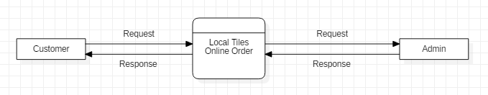

Screenshot: DFD of Local Online Tiles Order

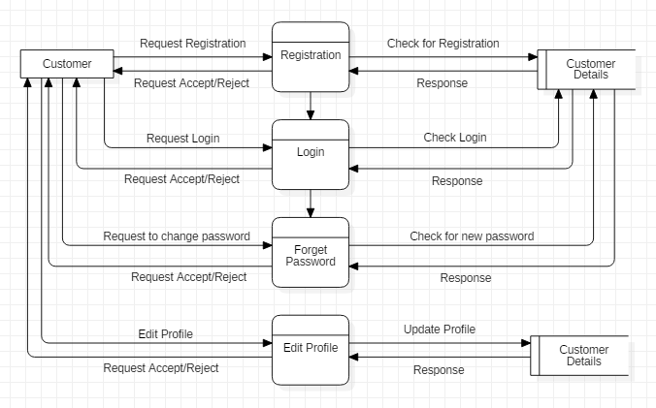

Screenshot: DFD of Customer Profiles

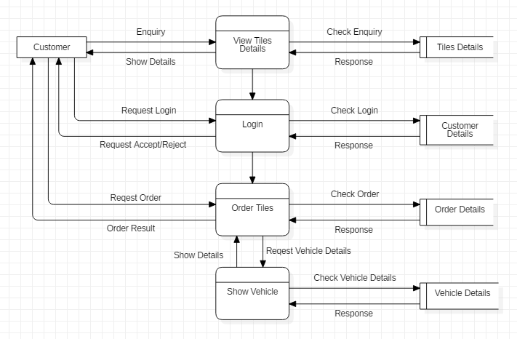

Screenshot: DFD of Customer Order

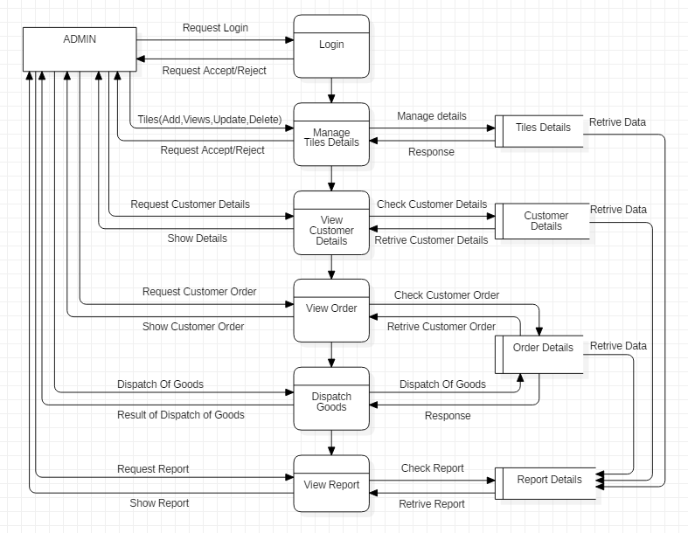

Screenshot: DFD of Admin

Reason for choosing Hard Approach and SSADM in my project is:

1. As I am familiar with the waterfall model and SSADM is more or less similar to the waterfall model. It will be easier.
2. As it uses the waterfall model each step were completed before starting the next steps. Which ensure that every procedure related to every step are undertaken.
3. Progress of every step can be measured easily by the help of objectives defined for each step

## 2.3 Feasibility Study

A feasibility study is a study that is used to measure or finds out whether the project is feasible in all the relevant factor before it has been developed. Some relevant factor that the feasibility study addressed is technical, cultural, economic, operational and schedule.

Since it is part of the analysis it plays an important role in completing the project successfully which are:

1. By identifying almost all the project related problems and providing alternative solutions.
2. It also helps to know the level of acceptance of the project by the users before the project finished.
3. It also helps to know if it is worth to invest in the projects or not.

There are different types of feasibility study. Some of them are:

1. **Technical Feasibility:** Technical feasibility is the study about whether the technical resources required to undertake the projects successfully are available or not. It also analyzed if the existing technologies in the company can execute or support the system after it has been developed.
2. **Cultural Feasibility:** This is one of the feasibility studies that help to know whether there will be a positive or negative impact of the project on both local and general culture. Once it deployed in a real environment.
3. **Economic Feasibility:** In this feasibility whether the project is economically feasible or not is measured or identified. That means do the profit gain from the new system exceeds or greater than that of the cost required to develop a new system.
4. **Operational Feasibility:** This feasibility study identifies certain problems, its importance in the project and alternative solution to solve. It also analyzed whether the developing system is easier for users than the existing system.
5. **Schedule Feasibility:** The most important feasibility study for the successful completion of the project. It allocates time for the different module development and measure if there is time available to do the project. It also determines whether or not the project can be completed within the given deadline.

## 2.4 Requirement Analysis

### 2.4.1 Functional Requirement

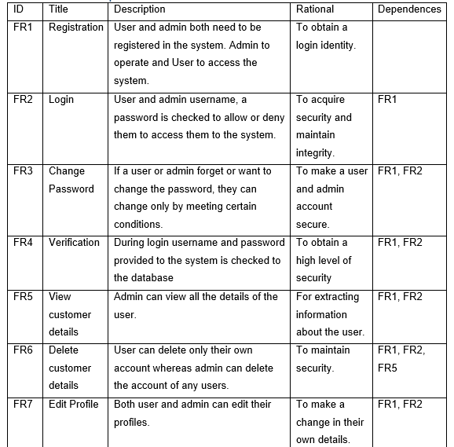

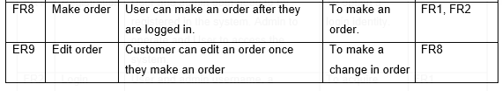

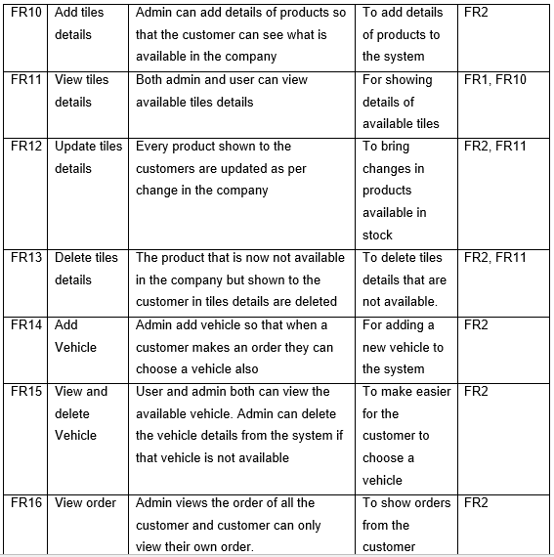

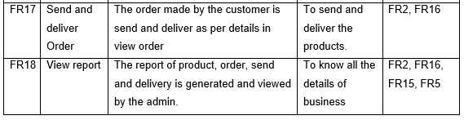

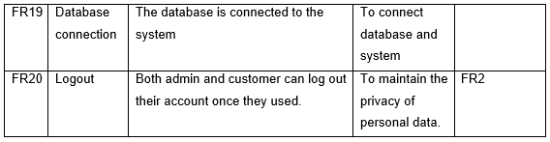

### 2.4.2 Non Functional Requirements

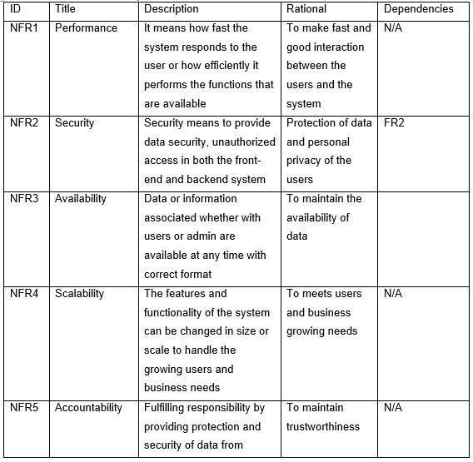

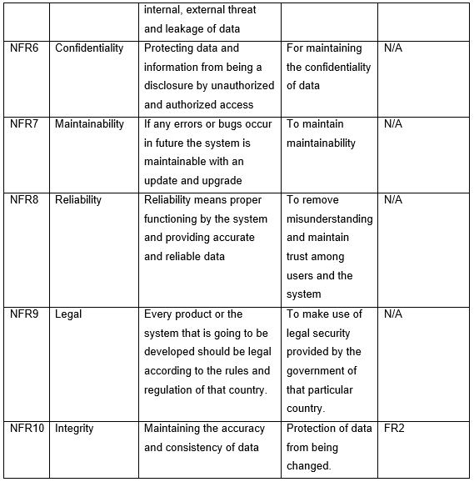

### 2.4.3 MoSCoW prioritization

MoSCoW prioritization is a technique which is used to prioritize the functionality and non-functionality requirement of the system. Which means every functionality and non-functionality of the system are not equally important, some of them can highly use, some can be the least use and some may not be used. So, to prioritize the functionality I used MoSCoW which means Must have, Should have, Could have and Won’t have.

**Must have**

Any functional and non-functional requirement which are guaranteed to implement and must be to make the system perform.

**Should have**

Requirements which are important to the system but they are not vital. So, if included they add significant value and if not included the system still function.

**Could have**

Requirements that are not required to perform the core function of the system. Compared with should have they have less impact on the system if not include.

**Won’t have**

Any functional and non-functional requirement which are not included and prioritized in a specific version but can be included in the upcoming version.

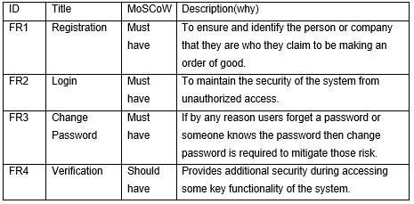

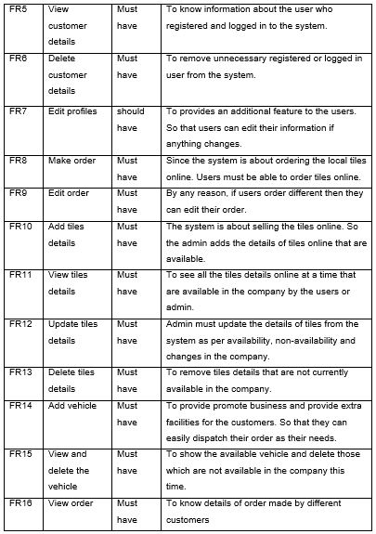

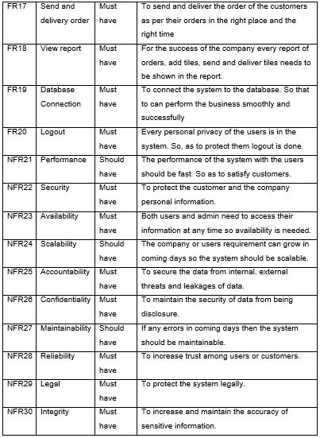

### 2.4.4 System Requirement Specification

A System Requirement Specification is a complete described document of the system to be developed. Which include non-functional, functional and features of the system. System Requirement Specification also describes the user's interface, hardware, and software requirements required to develop and run the system after being deployed in the real world.

The software and hardware required for my projects are listed bellows:  
Pre-project requirements: All the software and hardware required for completing the system from requirement gathering to deployment stages.

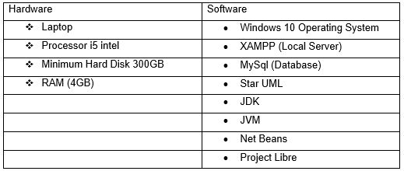

Post Project Requirement: Hardware and Software which are required at least a minimum requirement to run the system in the users existing systems.

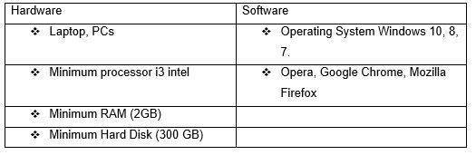

## 2.5 Use Case Diagram

Use Case Diagram is a visual and textual representation of a user’s interaction with the different use-cases of a system. It also shows the relationship between the system, actor, and use-cases.

To draw use case diagram different notation are used which are as follows:

* **Actor:** A role played by the customer in the system with defined roles to interact with the use-cases in the system.
* **Use Case:** Steps or functions of the system which represents a user goal and can be achieved by accessing the system.
* **System:** Represent by a shape in which the system use cases are placed inside it.
* **Relationship:** Notation that shows the relationship of use-cases between and among customers.

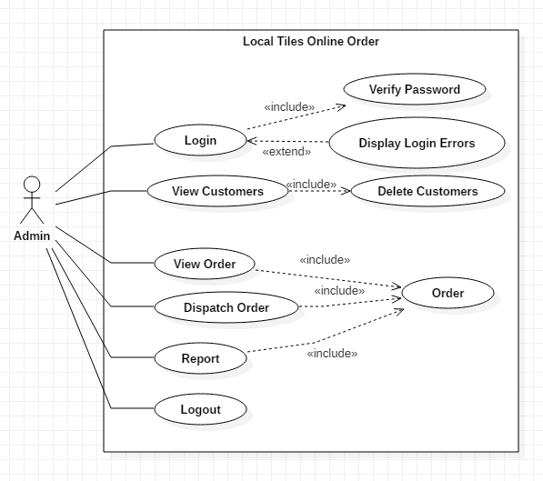

Screenshot: Use Case from the admin

Above use-case shows the functionality that actor(Admin) can access:

* At first admin login to the system then can access the functionality of the system.
* Admin views customers detailed information and can also delete the customer as per needs.
* Tiles order by the customers is also viewed by admin and dispatch orders as per information provided by customers.
* Admin generates a report of orders and customers at the end of the day and Log out the system to maintain security.

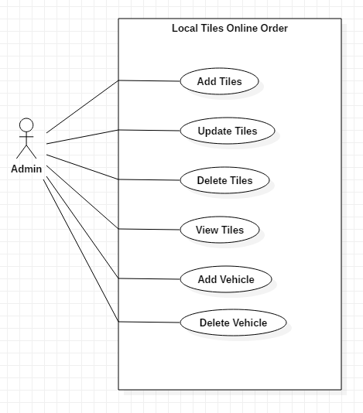

Screenshot: Use Case of Admin

Above use case also show the functionality than actor(Admin) access:

* To access this functionality also the admin first Login to the system.
* Admin adds tiles detail at the starting of the day and deletes, update details at the end of the day.
* Admin too adds new vehicles detail if needed and delete if not available.

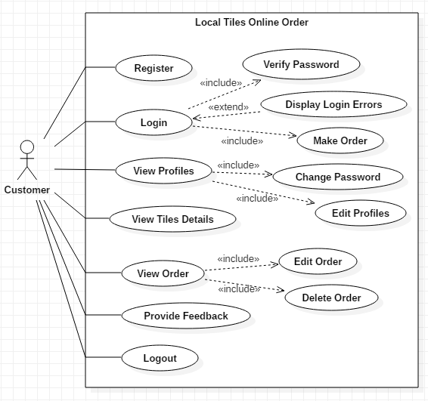

Screenshot: Use Case of Customer

The above use case shows the functionality that actor(Customer) can access:

* Customer-first needs to register and then log in to access some key functionality.
* Customer can view details of tiles available in the company.
* They can place an order and select a suitable vehicle to transport their order.
* They can edit and delete their orders, profiles as their needs.
* Customer can provide feedback about the systems and products.
* Finally, customer Logout to the system to secure privacy.

## 2.6 Natural Language Analysis(NLA) and Initial class diagram

Shreesh Tiles Company is a small scale industry located in Galkot, Baglung. Till now all the works of the company is done manually and with phone calls. So the owners of the company now want to computerized whole systems.

The company wants the system where there will be two users Admin and Customers. Admin or the owner of the company can add, update and delete details of products and vehicles. The owner also can see all the details of the customers and order place by customers then dispatch the order as information provided by the customers. In the other side, customer can see all the details of tiles available in the company but need to register to place an order. Once they register and place an order they can edit or delete their profiles and order as their needs.

From the above scenarios, Natural Language Analysis(NLA) is performed and candidate classes and method are separate from nouns and verbs.

|  |  |
| --- | --- |
| Candidate Classes | Candidate Methods |
| * Admin | * Add |
| * Customer | * Update |
| * Product | * Delete |
| * Order | * Register |
| * Vehicle | * Login |
|  | * Generate Report |
|  | * Change |

**Initial Class Diagram**

Initial Class Diagram is a static diagram that helps to define the structure of the system by showing classes and attributes that fall under it, operation of the system and relation between them. The initial class diagram also shows initial classes of the projects that further help in making a final class diagram.

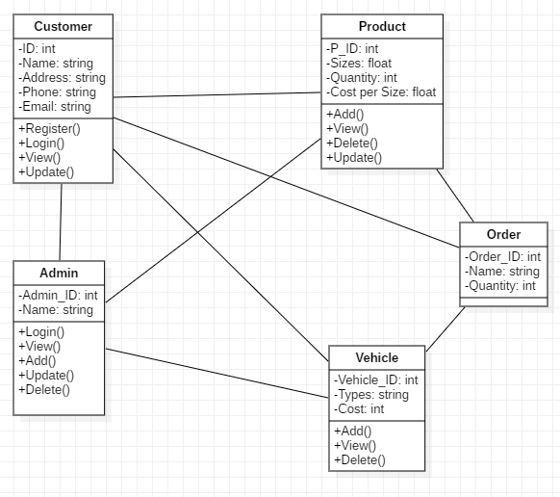

Screenshot: Initial Class Diagram

# Chapter 3: Design

## Introduction

This is a third phase, which shows how the system looks, runs and perform a certain function that is used by customers. As it includes application, database, user interface, and system interface design.

In the Design phase, I am modeling design into five types which are Structural, Behavioral, Database, Architectural modeling, and Prototype design. Inside these different types of design, there will be sub-design also. As the design is important in every project. So, in my projects also design plays an important role by changing the SRS documents into a logical structure. That logical structure contains a detailed and complete set of description that can be implemented in a programming language and design ensure successful completing of the project. So, I am doing a design phase in my projects.

There are five types of design which are:

## 3.1 Structural Modelling

A system view that depicts the objects structure, with their relationship, attributes, operations, and classifiers. Structure of the system design is display and it is a static model.

Some of the diagrams that include structural modeling are:

* Class diagram
* Object diagram
* Flow chart

### 3.1.1 Final Class Diagram

The class diagram is a static diagram that describes the system structure showing attribute and classes that include in system, operation, and relation among them.

Reason for making a final class diagram in my projects are:

* The final class diagram provides detailed of classes, attributes, operation, and relation.
* Object-oriented language can be directly mapped by a class diagram.

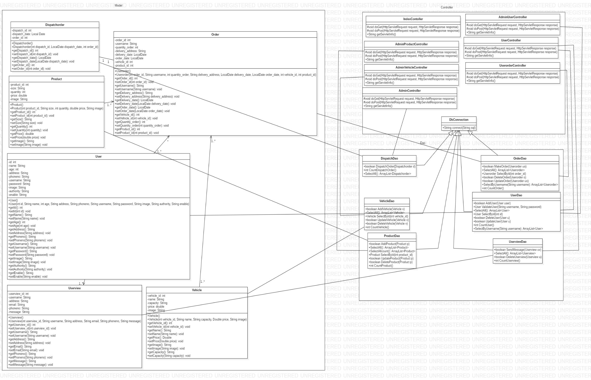

### 3.1.2 Flow Chart

The flow chart is a symbolic or diagrammatic representation of a logic sequence. The flow chart is represented by using different symbols that contain information about the process steps and every symbol are linked with arrows to show flow direction of the process.

Reason for making a flow chart in my projects are:

* Provide graphical representation which helps in my project to identify the process of different elements.
* It shows activities involved in the projects and analyzed problems can be done in more effective ways that help in managing time, reducing costs.

The basic symbols of the flowchart are:

1. The Oval: A Beginning or an End

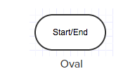

Used to depicts the start and end of a process.

1. The Rectangle: A step in the flowchart process

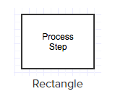

Used to show the process step

1. The Input/Output

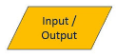

Used to represent data input/output to or by users.

1. The Arrows: Directional flow

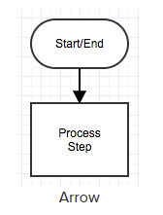

Depicts the flow of steps.

1. The Diamond: Call for Decision

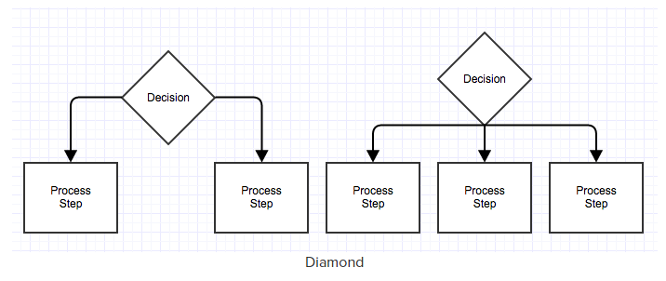

The diamond symbol used to make a decision.

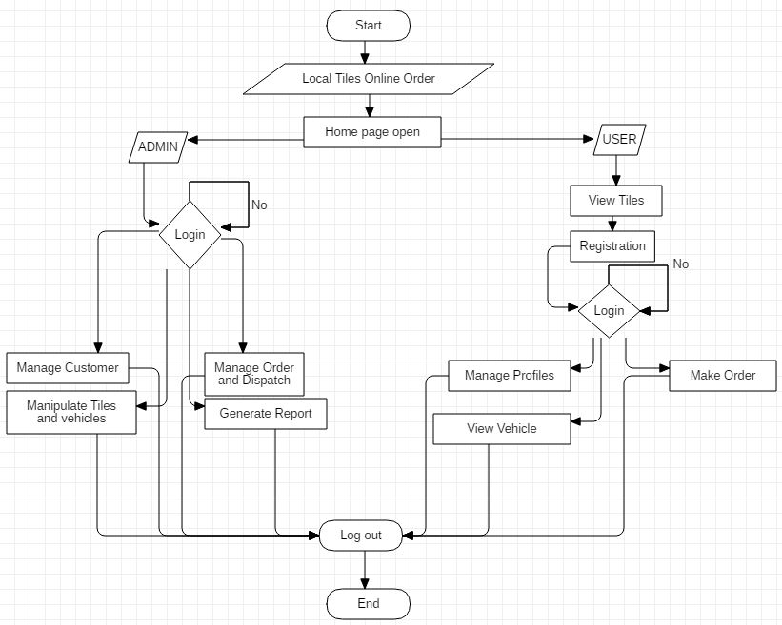

Figure: Screenshot Flow chart of Admin and user

The above flow chart diagram shows the overall functionality that a user and an admin does. First both user and admin open homepage of the company.

If it is an admin then it open login page and admin logged in to the system providing required login credentials. Once login success system show admin dashboard where admin can manage customer, manipulate tiles and vehicle, view order, dispatch order and generate reports. Else a user can view available tiles then if the user wants to make an order, manage profiles, and view vehicle user needs to register to the system and then logged in to perform that functionality. Once both user and admin finished performing their functionality they log out from the system.

## 3.2 Behavioral Modelling

The behavioral diagram is a dynamic diagram and depicts the functionality of the system. It includes a diagram like a use-case, activity, collaboration and sequence diagram.

### 3.2.1 Activity Diagram

Activity diagram is used to depict system behavior. A graphical representation of a series of procedural system activities to another activity.

Reason for making activity diagram in my projects:

* It depicts action and activities of the system as well as outline workflow within/between use-cases.
* Models a high-level activity diagram in detail of complex activities.

Notation that is used in my project to make an activity diagram are:

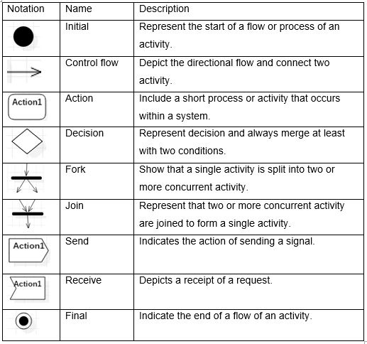

Activity diagram of Admin

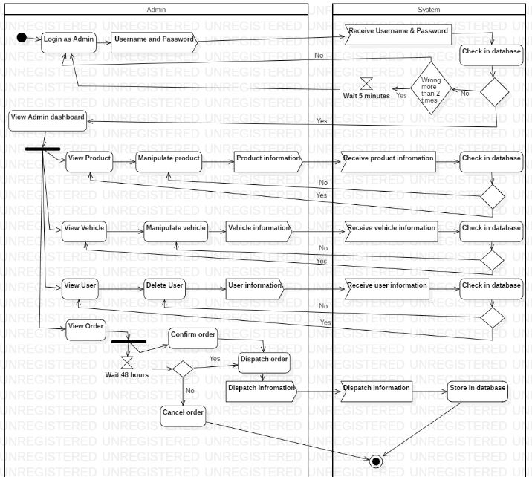

This above figure shows the flow of activity that is performed by the admin. First admin provides login credentials and system check provided login credentials in the database if matched then it the open admin panel else it redirects to the login page with an error message. After the login is success admin can view and manipulate product, vehicle, and users. Admin views the order and confirms the order once before it dispatches and also cancel the order if the users do not confirm their order within the time frame of 24 hours. At last, retrieving all information report generation in done.

Activity diagram of Users Order

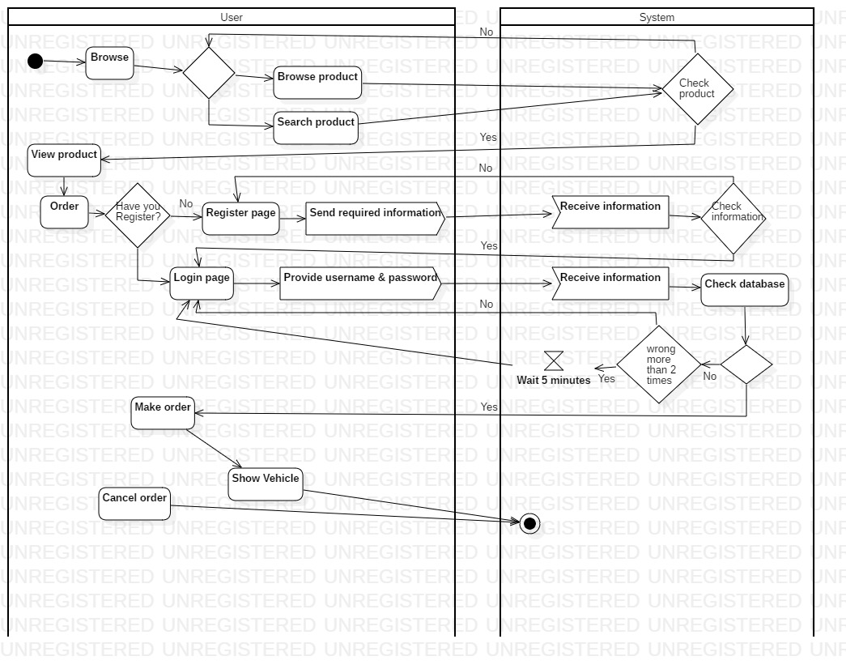

This activity diagram shows the flow of activity done by users during order. After the user browses to homepage user can view available products in the company else can search product as need. If the no product is available then it redirects to the homepage.

When a user wants to order and click on make order button then the system asked whether the user is register to the system. If no system open the registration page and user provide required information and system validates register credentials of users then redirect to the login page when success. Otherwise, if the user is registered system open login page so user logged in to the system and make an order. The user can cancel an order if they don’t want.

Activity diagram of User update profile

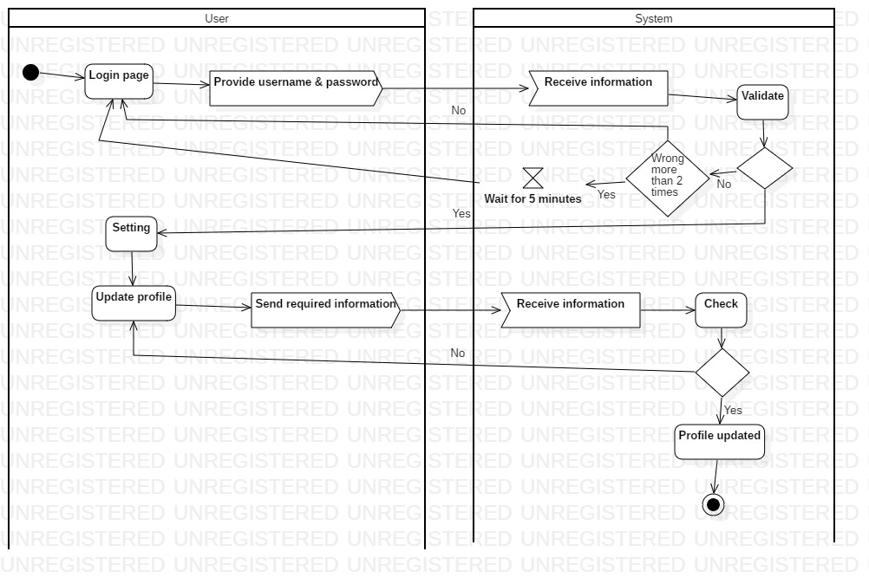

Above activity diagram is about both user and admin updating profiles. Firstly both user and an admin login to the system providing login credentials. If success then it shows setting where both user/admin can update their profile providing information that they want to update. If not the system redirects to the login page.

### 3.2.2 Sequence Diagram

An interaction diagram that depicts how operations are carried out in a time sequence -- what and when messages are sent. Messages passed among the objects within the use-case in a number of objects are shown.

Reason for making sequence diagram in my projects are:

* It depicts logic interaction between the objects in sequential order.
* Show the interaction between objects within cooperation that understand the operation and use-cases.
* It depicts the use-case in a visual format.

Notation that is used in my project to make a sequence diagram are:

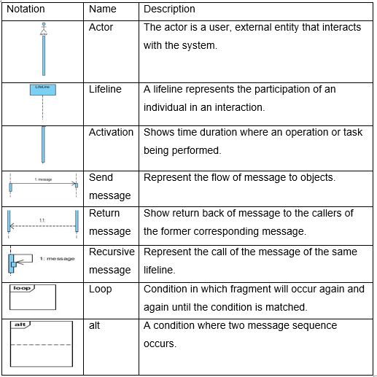

Sequence diagram of Register:

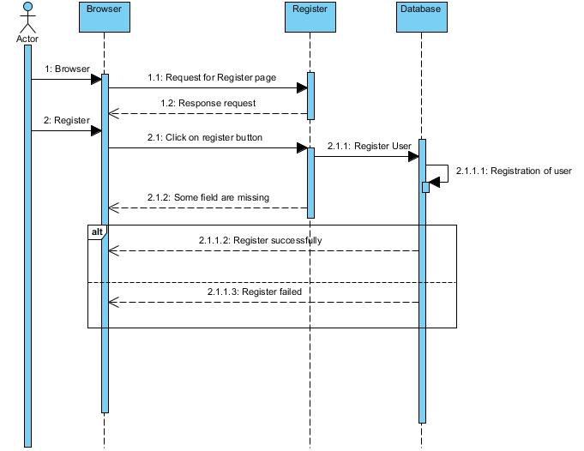

Above sequence diagram is about registration of the user to the system. First user browser the home page of Local Tiles Online Order then request for registration page and fill up all the required credentials then send to the system. The system checks the information provided by the user then if any fields are missing then it sends errors message otherwise it registers user and sends message to a user of successful registration.

Sequence diagram of Login:

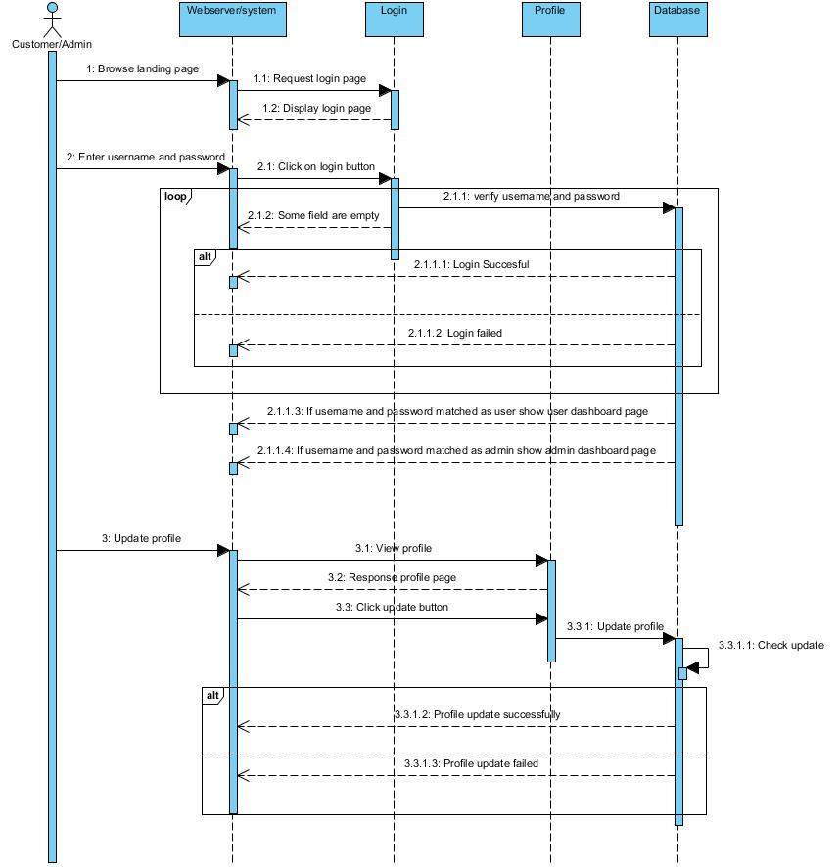

This a sequence diagram about the login of both users and admin. Here, user/admin open login page once they go to home page then provide login credentials to the system. The system check login credentials to the database. If login credentials are matched as admin then system opens admin panels or if matched as a user it opens user panel otherwise if there errors in username and password system display errors message to a user.

As for update profile, the user clicks on the update page and receive update form then they change their information that they want to update and click update buttons. The system receives information of the user if correct they send success message else errors message is sent to users.

Sequence diagram of Order:

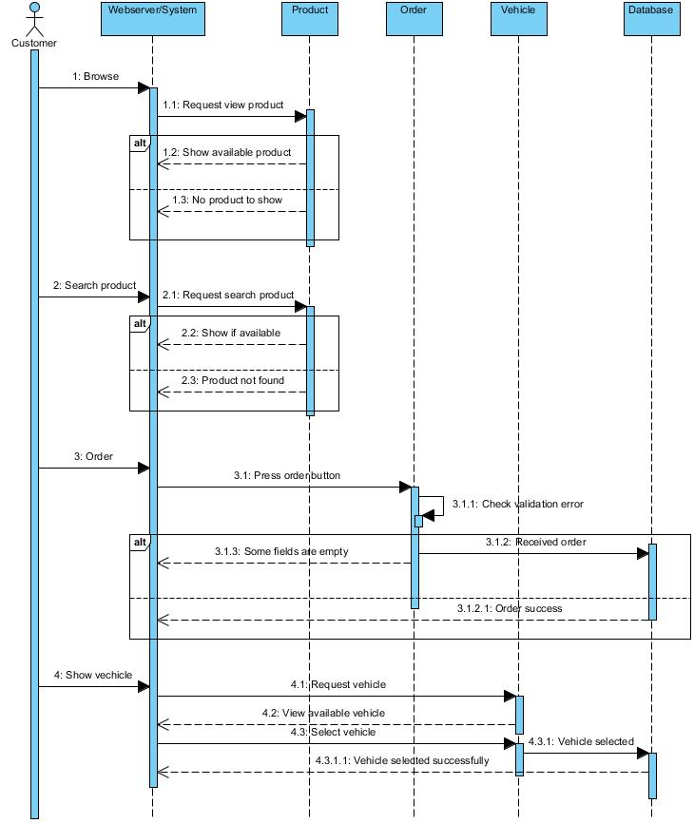

Above sequence diagram shows that sequence of order in the system. Once the user visits the home page then the user can view the available product or can search product. After they viewed product user can order by clicking the order button and providing the required information for the order. If all order credentials are correct then the user gets the message of successfully order otherwise user get errors message.

Then, the user can select the means of transportation to deliver their product if they like to use our means of transport after they order the products.

Sequence diagram of Admin:

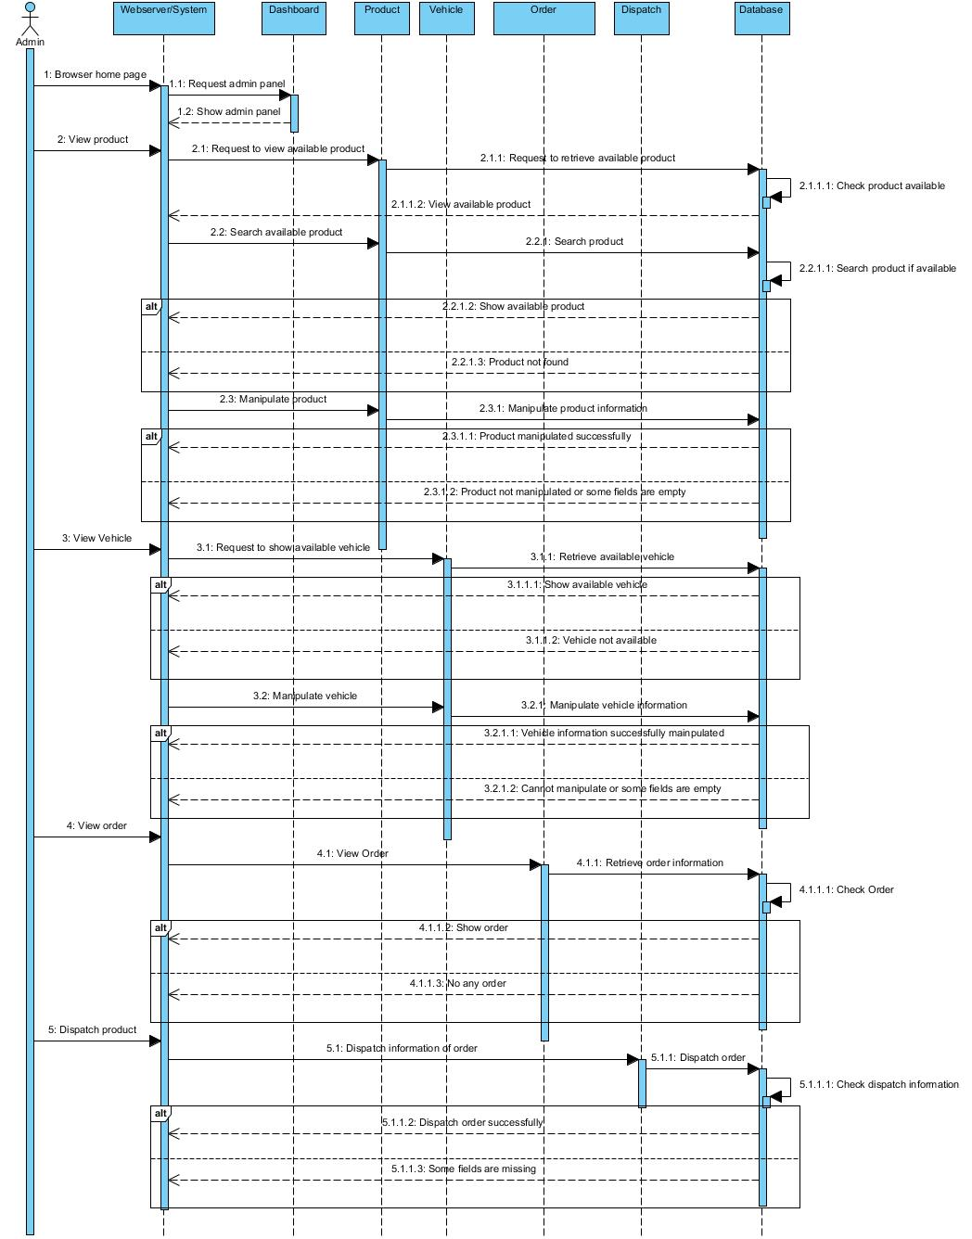

Above sequence diagram is about admin panel representing the flow of a sequence of admin activities. After admin open homepage admin can view current product available in stock. Admin can do CRUD operation for vehicle, products. Admin can delete unnecessary users and orders. Admin views the orders and dispatches orders as per information provided by users.

## 3.3 Database Modelling

Database Modelling is a logical structure and representation of the database. It describes how the data can be stored, processed and manipulated within it. In my project database modeling helps me in designing blueprint of the database that will make me easier to develop a system.

### 3.3.1 Data Dictionary

Data Dictionary is a set of information that contains database metadata. It describes the format, structure, and content like column name, data type, length, null, key and constraints of a database. Data dictionary also used to manipulate the database, to control access and shows the relationship between its different components.

Importance of data modeling in my projects are:

* It gives clear and well-structured information about the database.
* Data dictionary provide details for any new DBA and administrator.
* It is very difficult to remember almost every database since it may be large and may consist of lots of views, tables, constraints, index, etc. So by providing all the details, it helps users.

1. Data dictionary of Customer

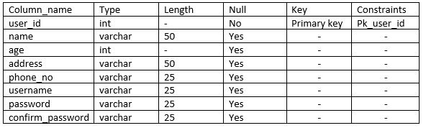

1. Data dictionary of Product

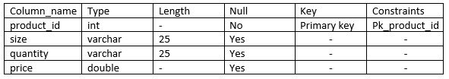

1. Data dictionary of Order

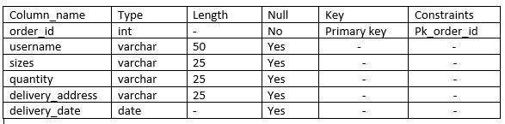

1. Data dictionary of Vehicle

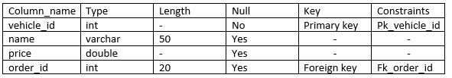

1. Data dictionary of Dispatch_Order

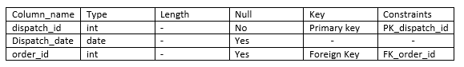

1. Data dictionary of Customer_Order

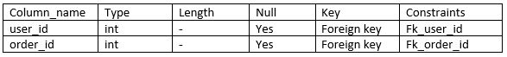

1. Data dictionary of Order_Product

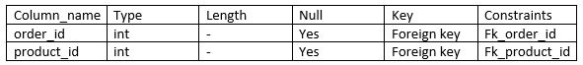

Each table has a column field name with six columns. First column column_name define data name of the database, what type of data is defined by column type, length column defines the length of data, whether data can be null or not is defined by null column, key column define if the data is primary or foreign or neither of them and constraints.

### 3.3.2 ER Diagram

Entity-Relationship(ER) diagram is a technique of data modeling that graphically depicts(represents) entities of an information system and relationship among those entities.

The components of the Entity-Relationship(ER) diagram are:

* Entities
* Relationships
* Attributes

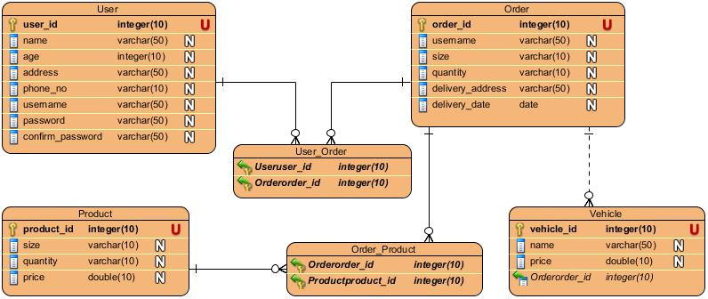

### 3.4 Architectural Modelling

Since my system aims and focuses to provide easy services to the customer without any interruption. So, I will be using Client-server architecture. The client-server architecture is a shared architecture where loads of client-server are distributed. The server holds all the resource in a centralized resource system. The client-server gets numerous performance at its edge for sharing resources to its customers when requested. In this architecture, the client and server may be in a network or on the same. Client services will not be interrupted in this architecture since it is service-oriented.

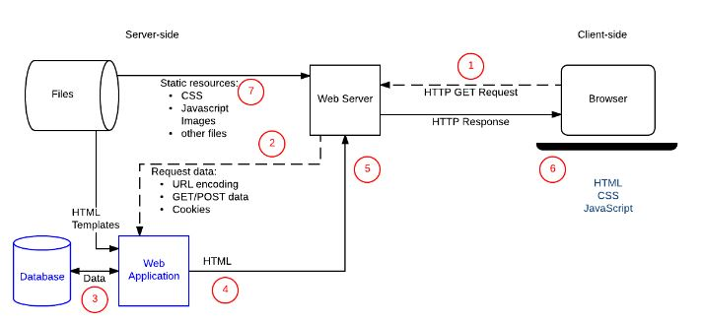

Screenshot: Client-server architecture

## 3.5 Prototype Design

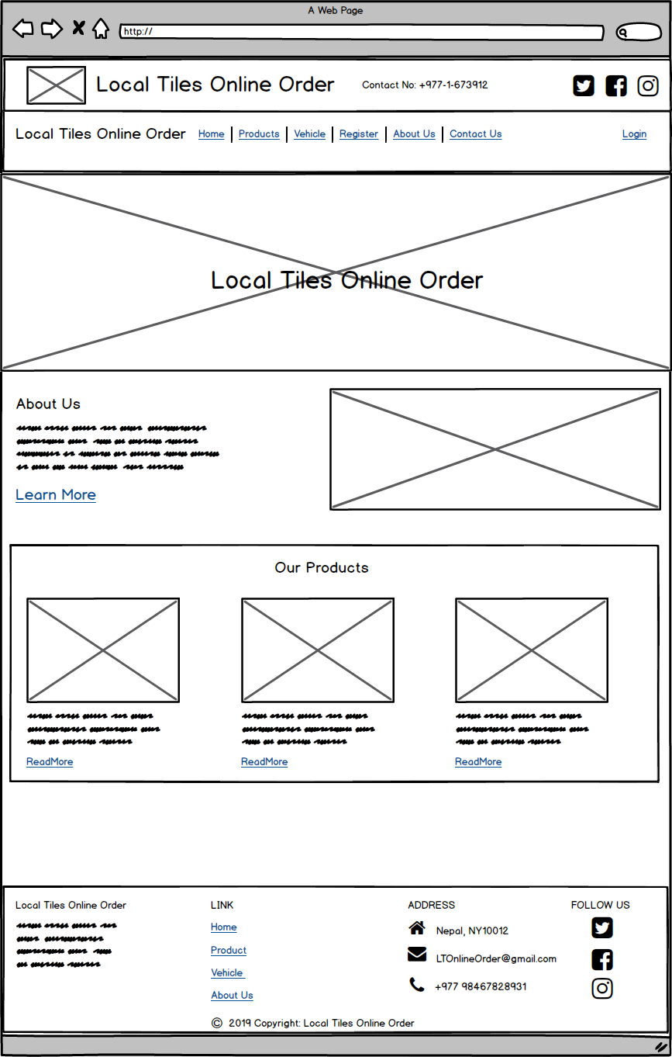

Screenshot: Home Page

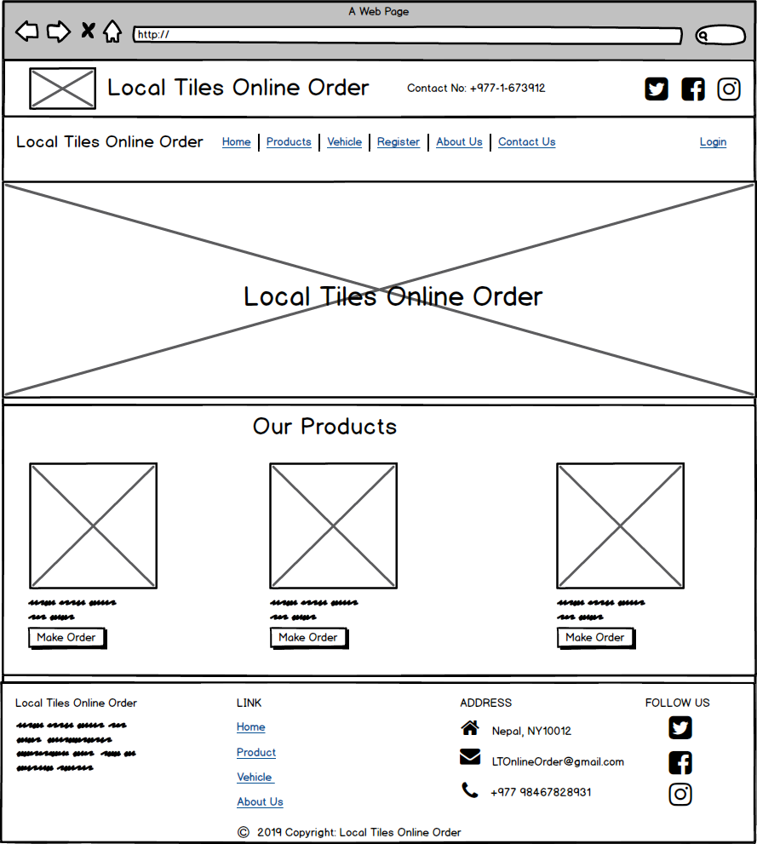

Screenshot: View product home page

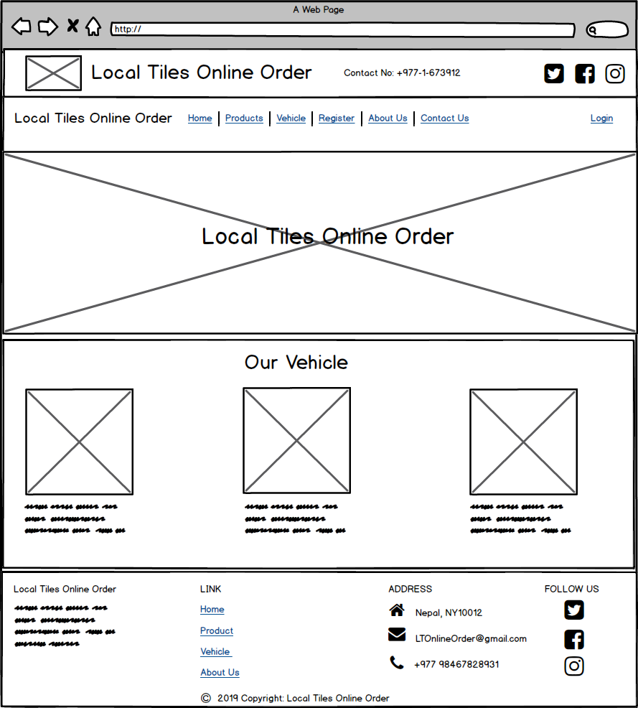

Screenshot: Our vehicle home page

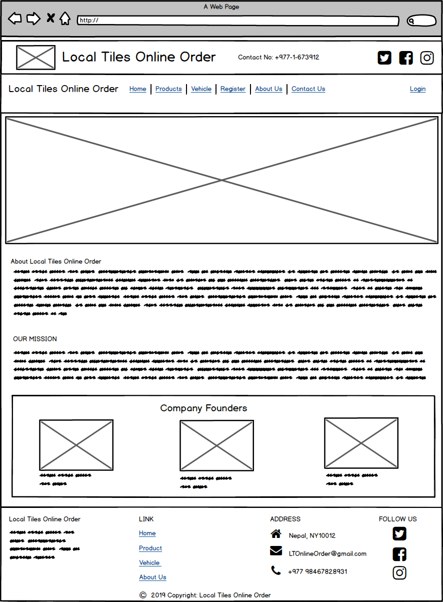

Screenshot: About us home page

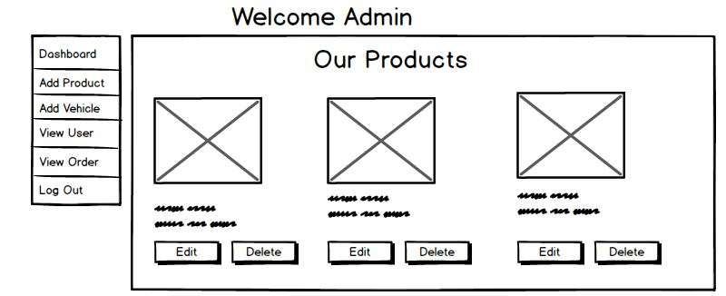

Screenshot: Admin home page

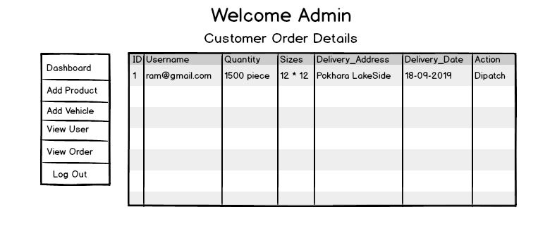

Screenshot: Admin view order

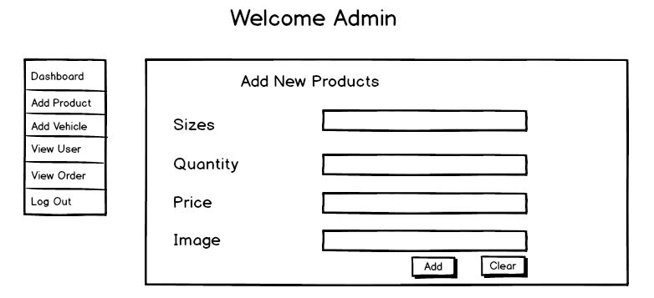

Screenshot: Admin add product

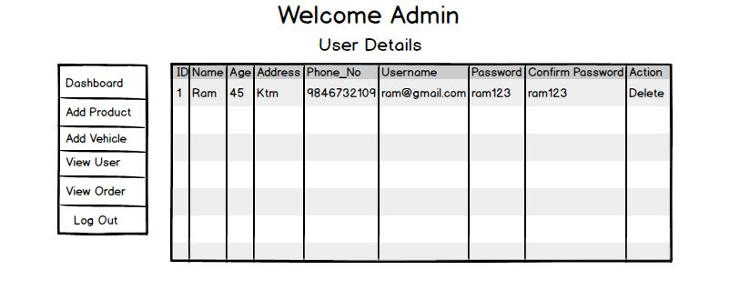

Screenshot: Admin view user details

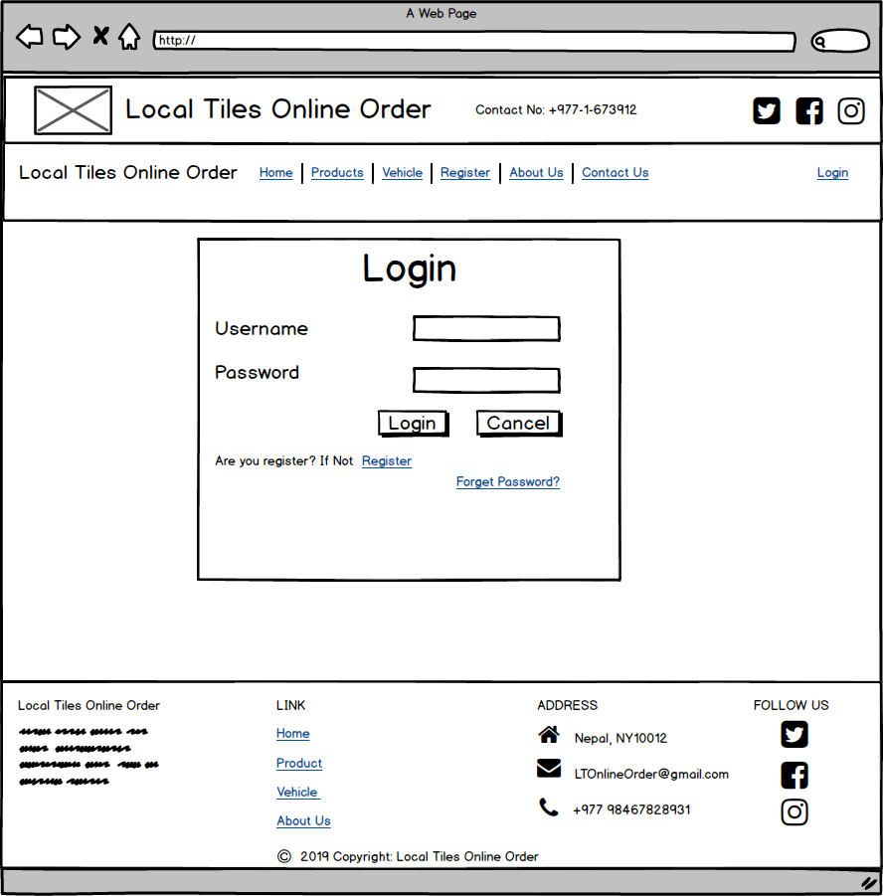

Screenshot: Login page

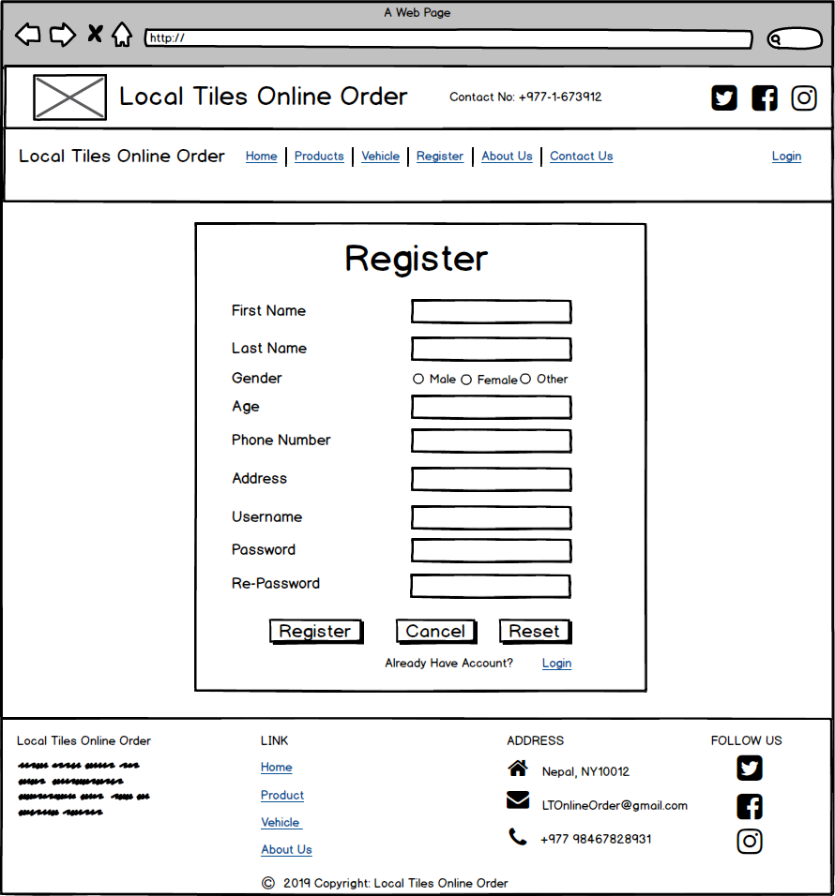

Screenshot: Register page

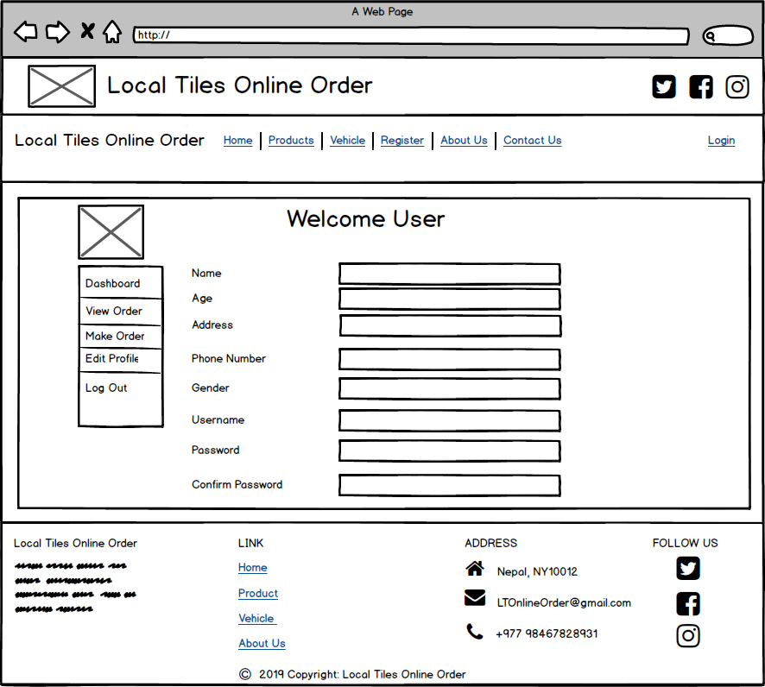

Screenshot: User dashboard

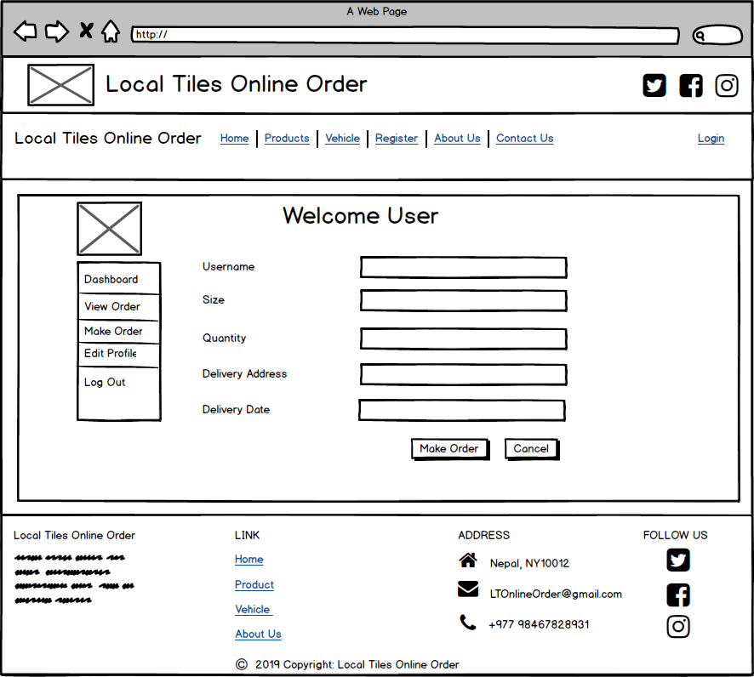

Screenshot: User Order

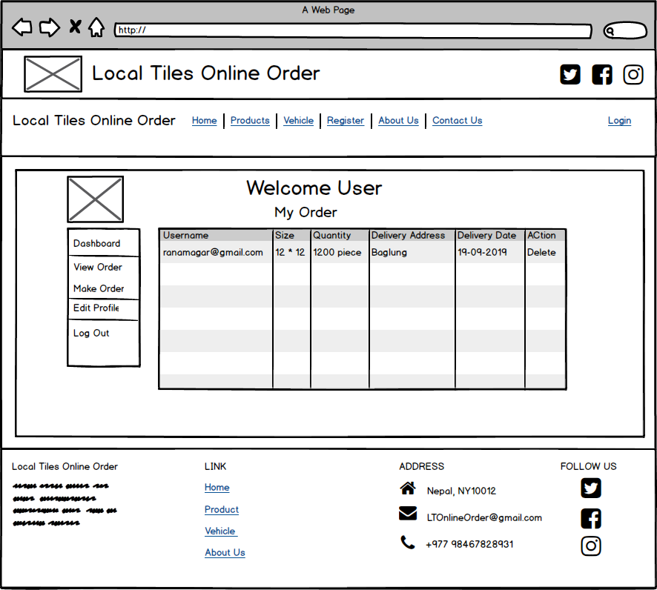

Screenshot: User view Order

# Chapter 4: Implementation (Coding)

## Introduction

This is the third phase of Structured System Analysis & Design Methodology (SSADM). Here, the system is directly introduced to an organization or run parallel with the existing system unless a new system works successfully.

In this phase, coding is also done. Here design model that shows how our systems look and work is converted into actual products. In the process of coding have used MVC design pattern which separate code into Model, View, and Controller. That directly helps in making code having less coupling and more cohesion.

## 4.1 Importance of coding:

* Coding helps us to write code which is efficient and easy for us to understand, read and write.
* With the help of the coding application, website, and so on are more easy and efficient to understand.

## 4.2 Tools Used:

To complete my project successfully some database software and Integrated Development Environment(IDE) tools are used for storing data and to write code for the development of the website. Which are:

For Database

* Xampp
* MySql

For Integrated Development Environment (IDE)

* NetBeans

## 4.3 Language Used

As for the successful development of my project, I have used different frontend and the backend language which are:

Back end Language:

* Java

Font end language:

* Hypertext Markup Language (HTML)
* Cascading Style Sheets (CSS)
* Javascript

## 4.4 Codes

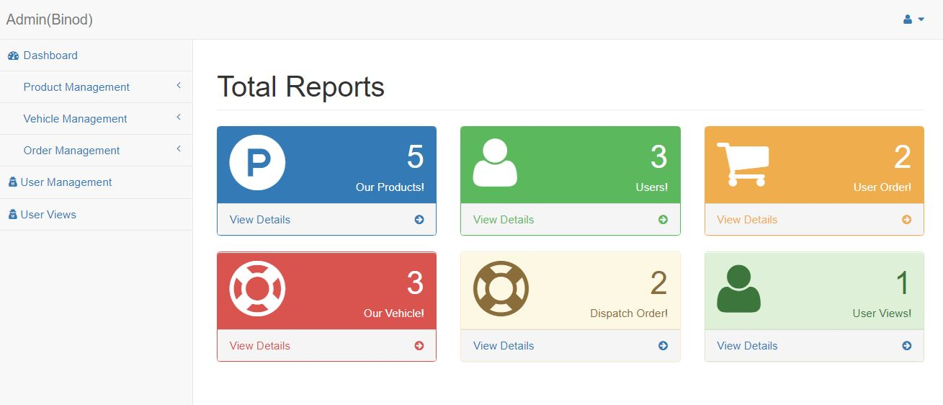

Screenshot: Admin Home

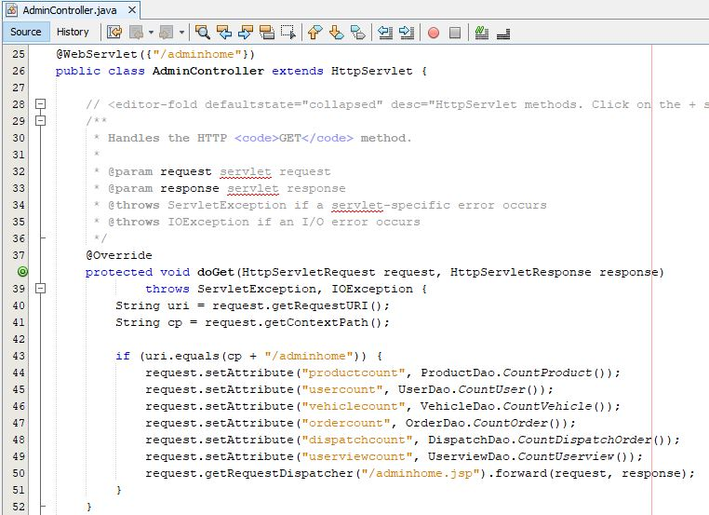

Screenshot: Controller for Admin Home

Admin manage product

Model for product

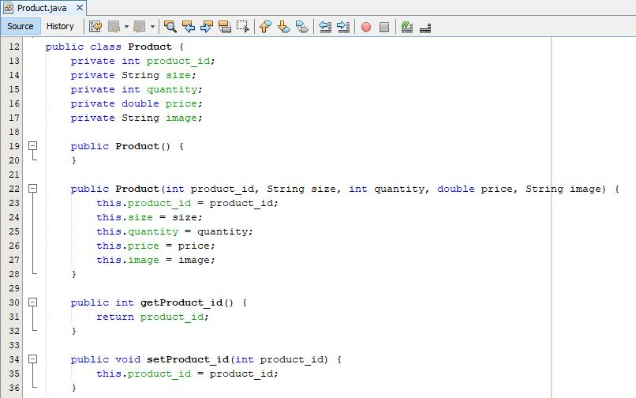

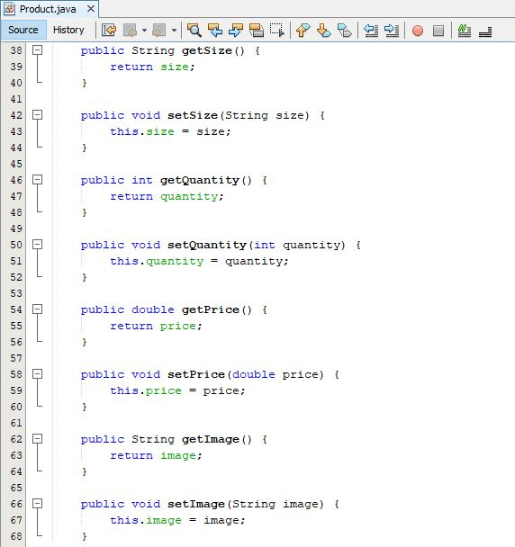

Controller for product

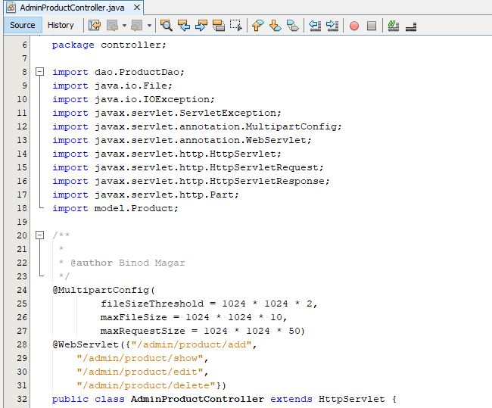

Screenshot: Imported Library and URL(Uniform Resources Locator) pattern for Product Controller

Admin product controller request in doGet and operation performed

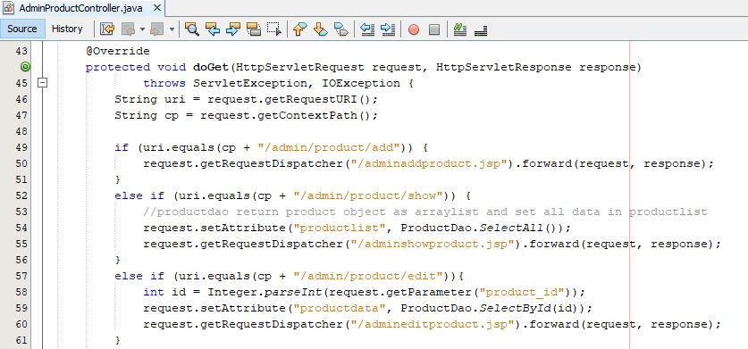

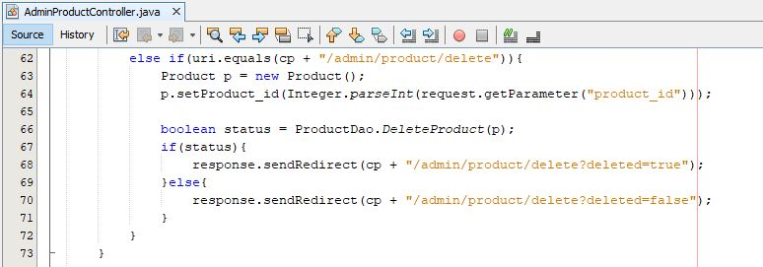

Admin product controller request in doPost and operation performed

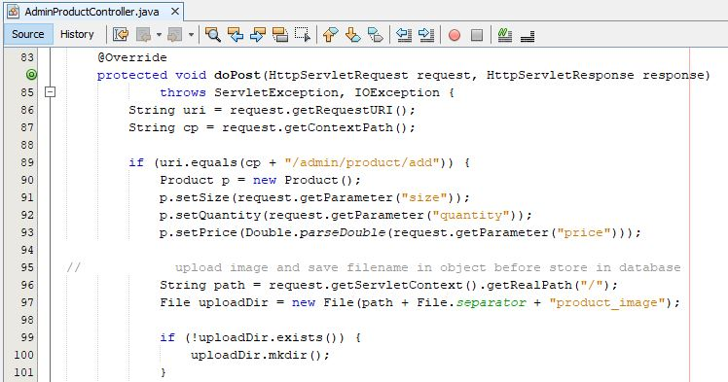

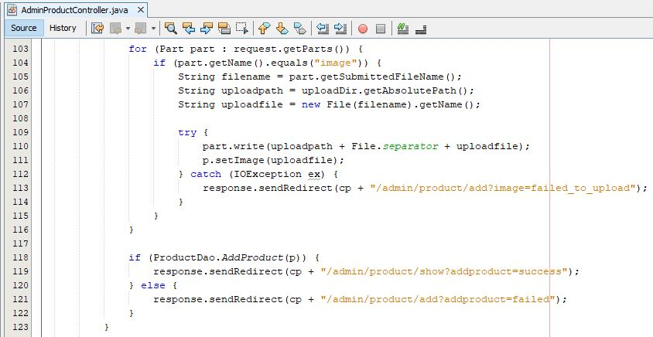

Screenshot: Controller to add product

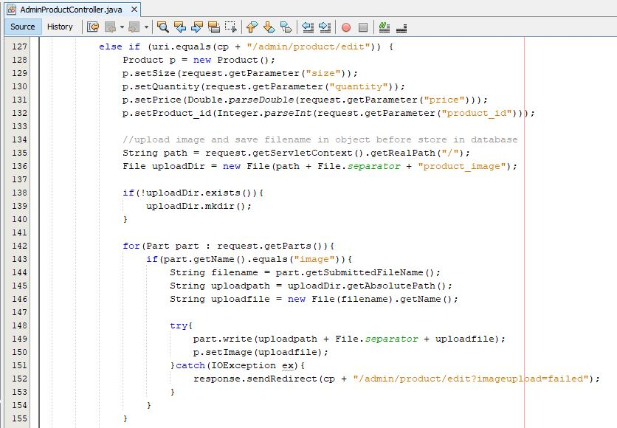

Screenshot: Controller to edit product

Admin product DAO(Data access object)

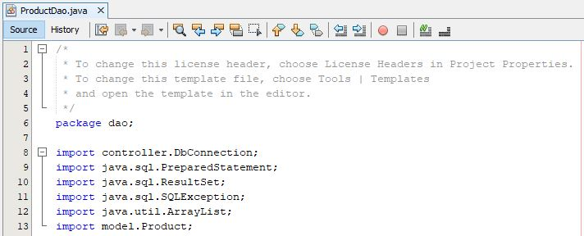

Screenshot: Imported library for Product Dao

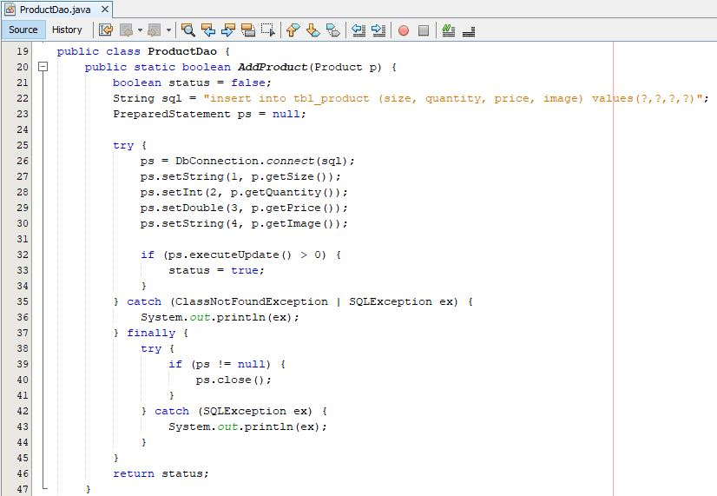

Screenshot: ProductDao of adding of product

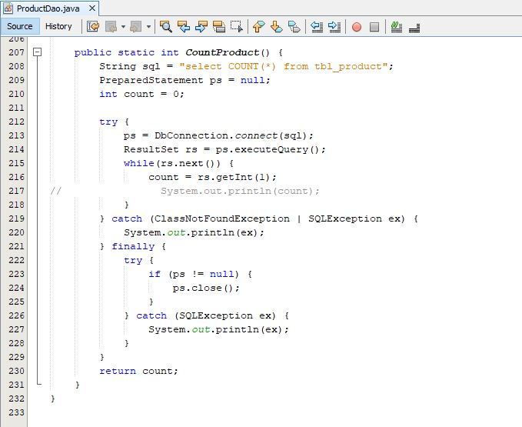

Screenshot: ProductDao for count total product

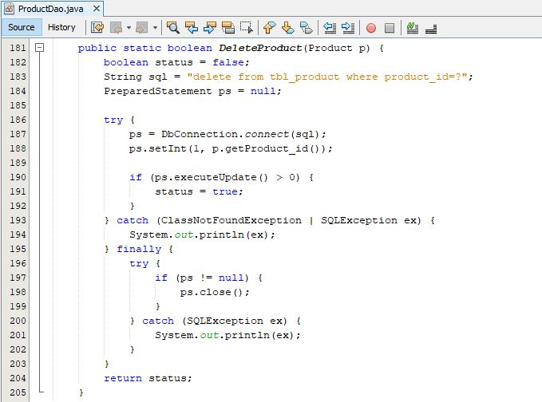

Screenshot: ProductDao to delete the product

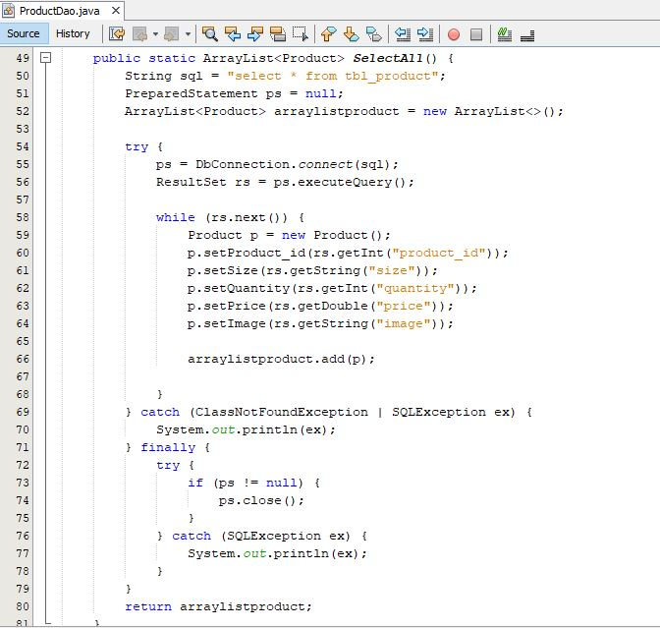

Screenshot: ProductDao to select all product in ArrayList

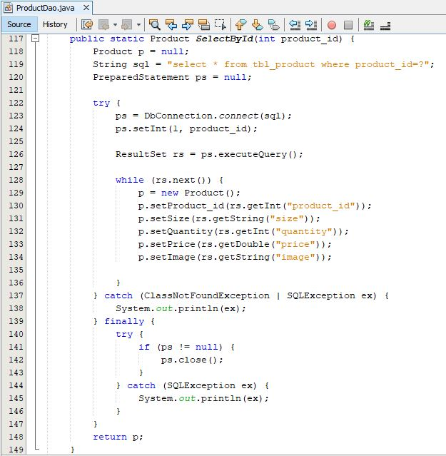

Screenshot: ProductDao to select a product by product id

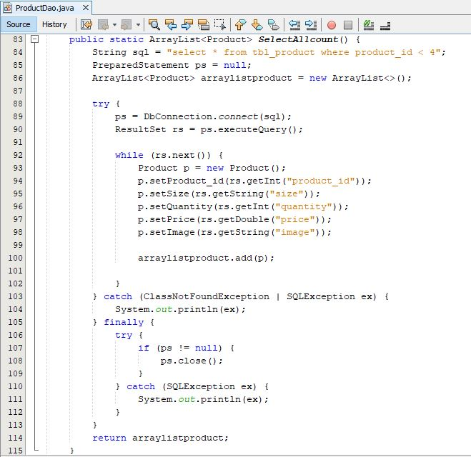

Screenshot: ProductDao for select product id less than 4

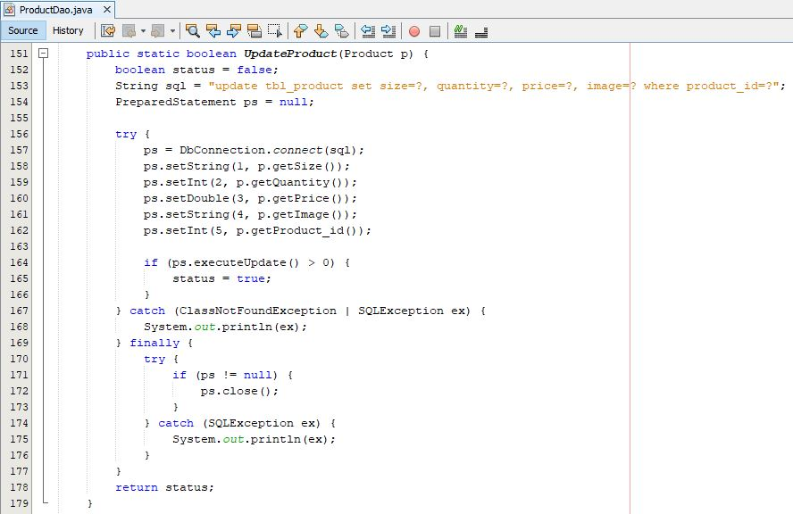

Screenshot: ProductDao to update the product

Form for Admin manage product

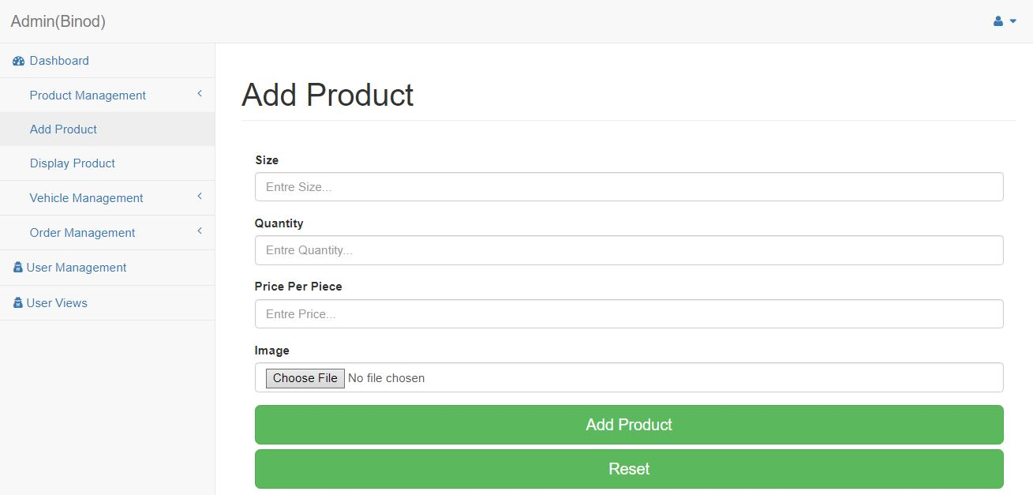

Screenshot: Form for add product

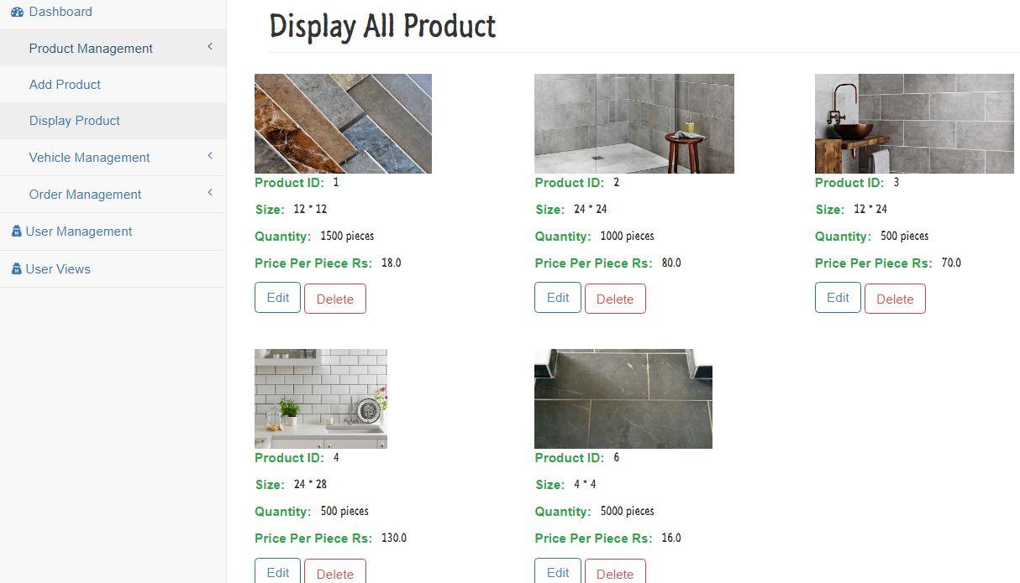

Screenshot: Display of all product

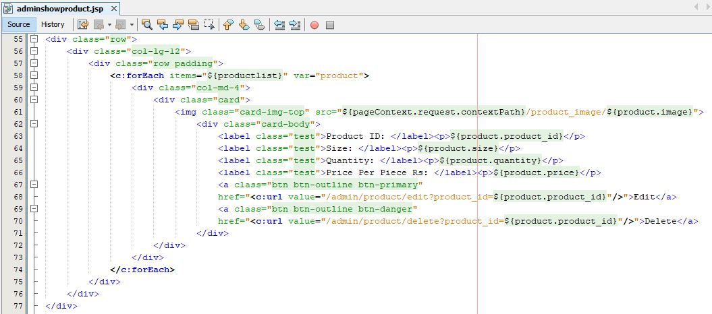

Screenshot: JSP file for display all product

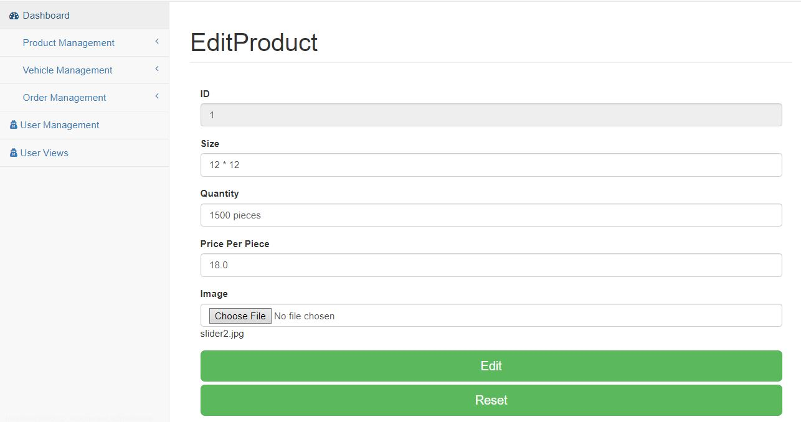

Screenshot: Form to edit a product by admin

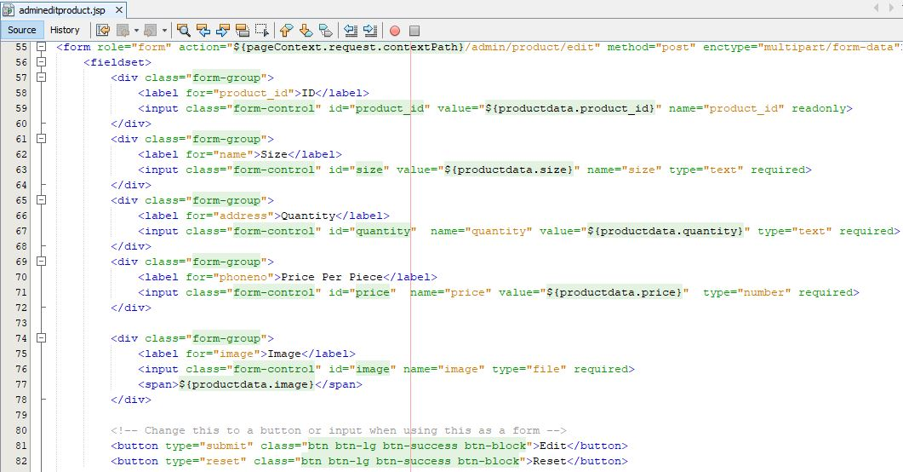

Screenshot: JSP(Java Server Page) to edit product

Admin manage vehicle

Model for vehicle

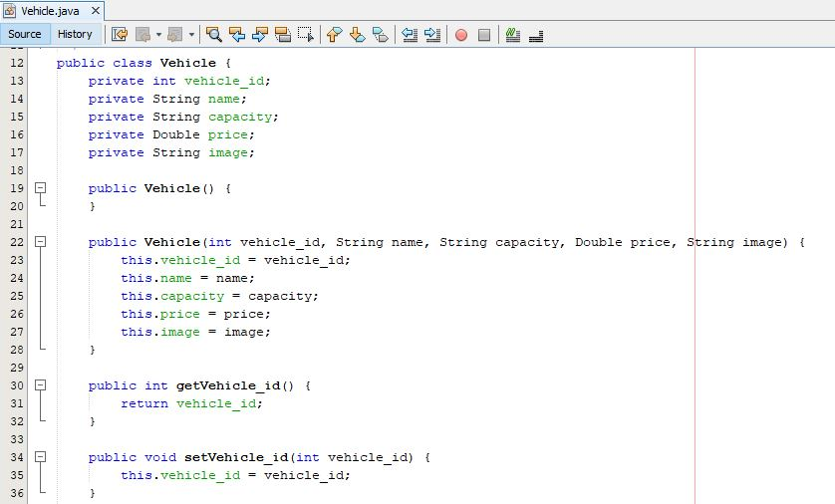

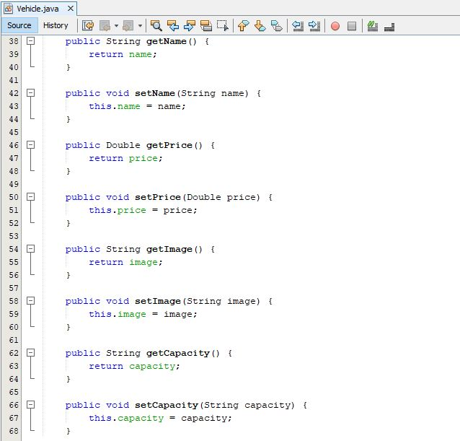

Controller for Vehicle

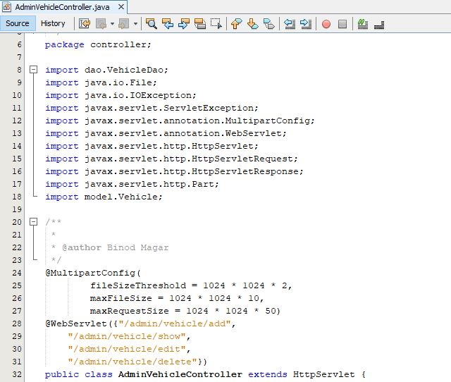

Screenshot: Imported Library and URL(Uniform Resources Locator) for Vehicle Controller

Admin vehicle controller request in doGet and operation performed

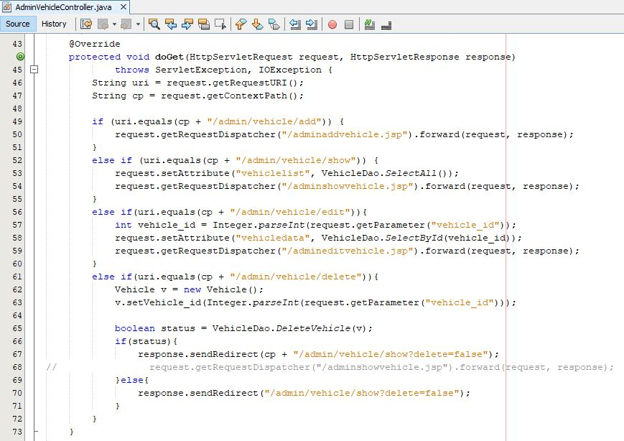

Admin vehicle controller request in doPost and operation performed

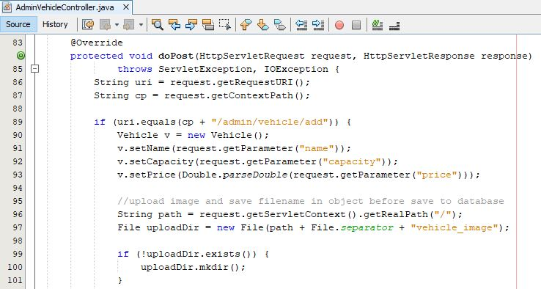

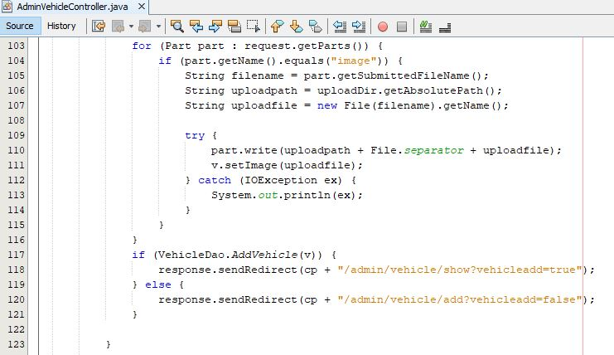

Screenshot: Controller to add a vehicle

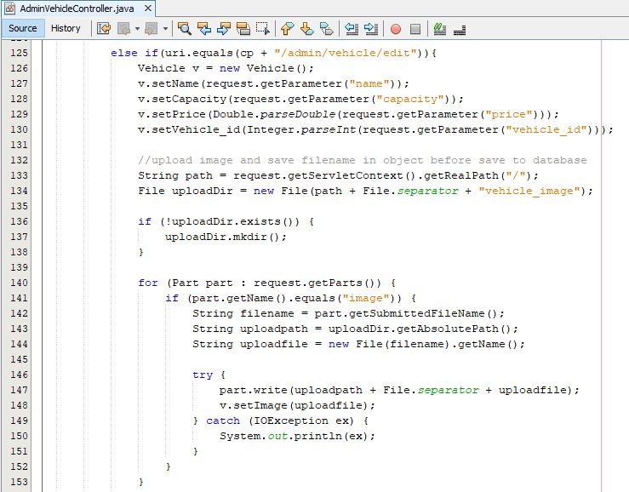

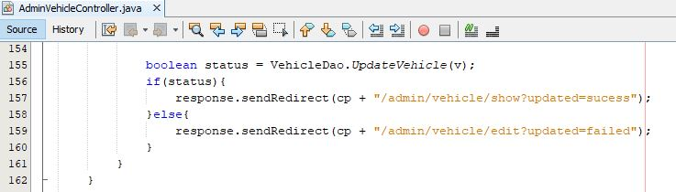

Screenshot: Controller to edit vehicle

Admin Vehicle Dao(Data access objects)

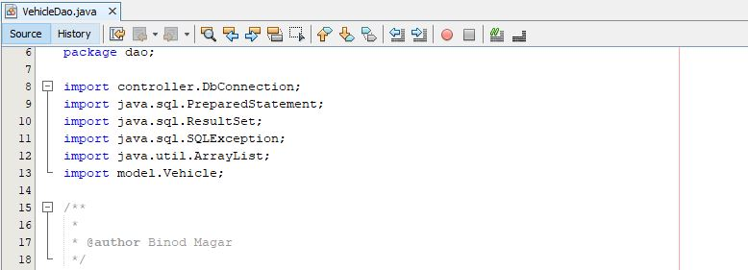

Screenshot: Imported library for vehicle Dao

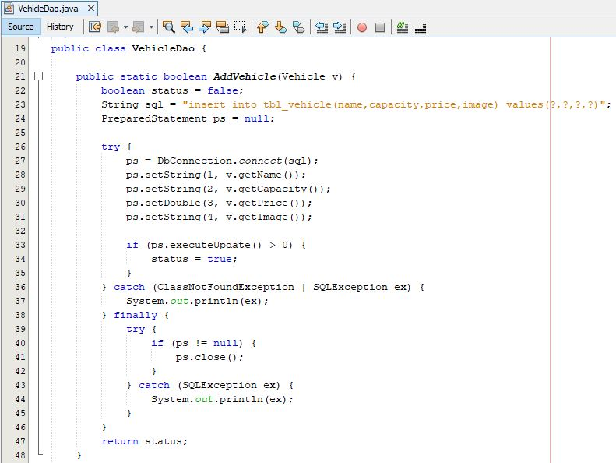

Screenshot: Vehicle Dao to add a vehicle

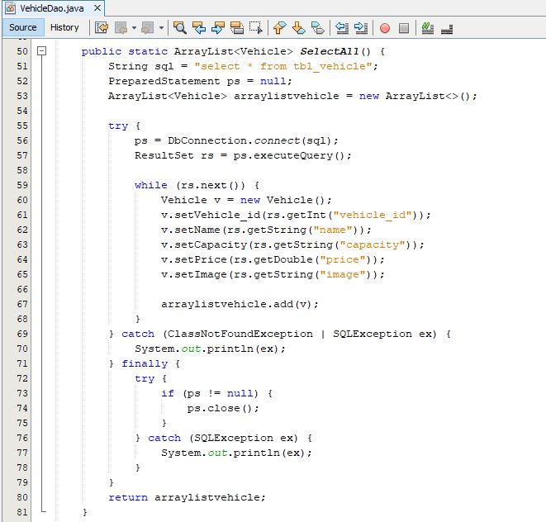

Screenshot: Dao to select all vehicle and store in ArrayList

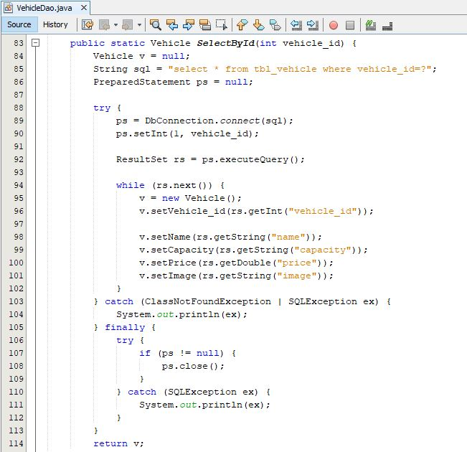

Screenshot: Dao to select a vehicle by vehicle id

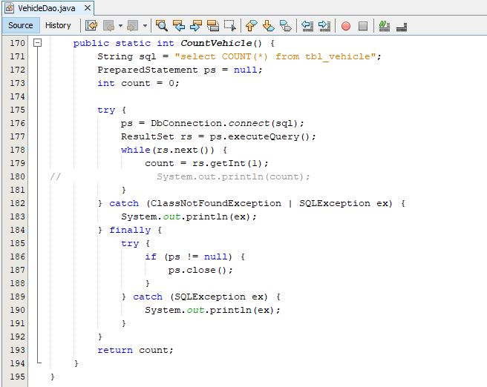

Screenshot: Vehicle Dao to count all vehicle

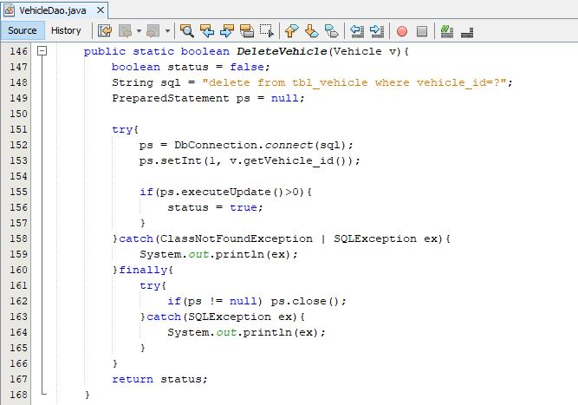

Screenshot: Vehicle Dao to delete a vehicle

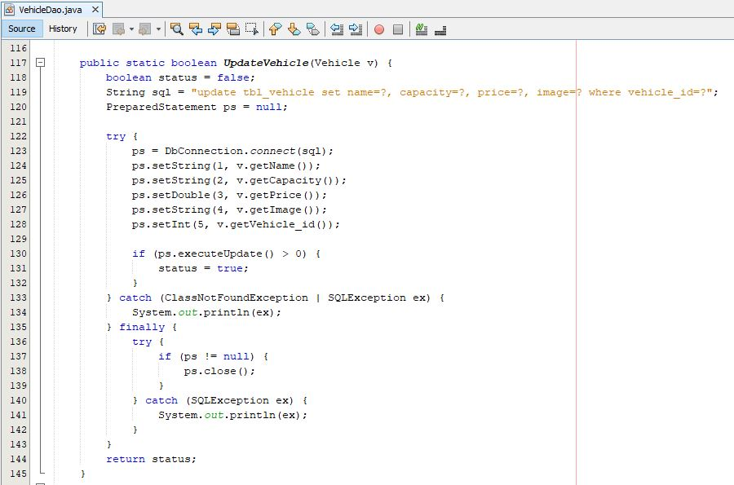

Screenshot: Vehicle Dao to update vehicle

Form to manage vehicle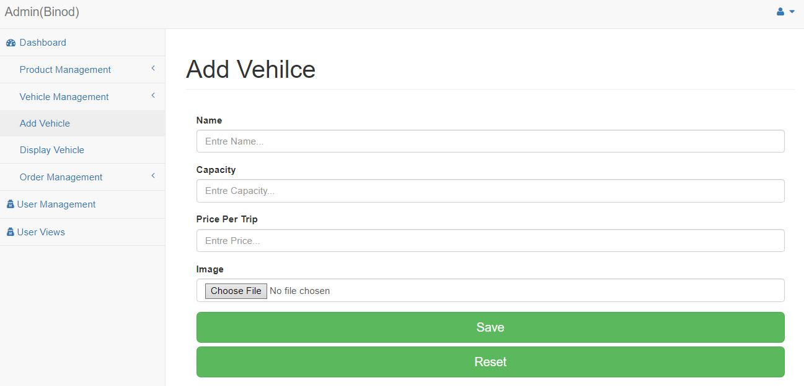

Screenshot: Form to add a vehicle

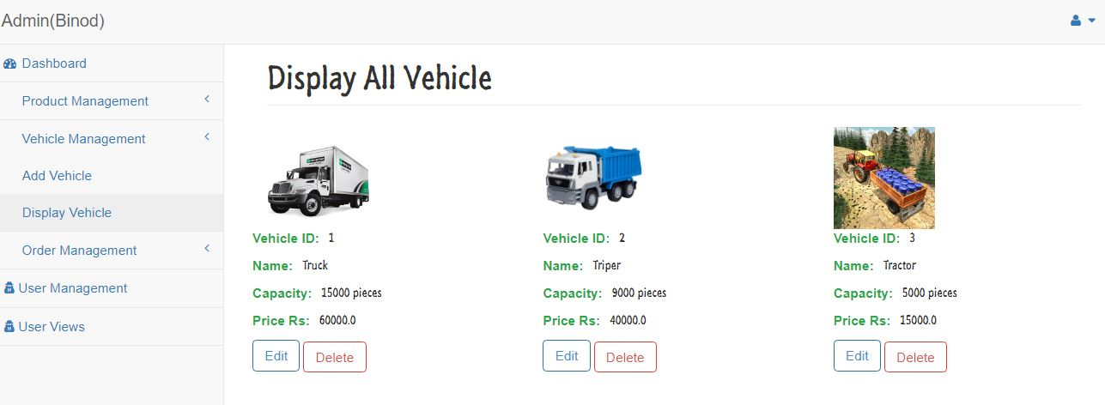

Screenshot: Form to display all vehicle

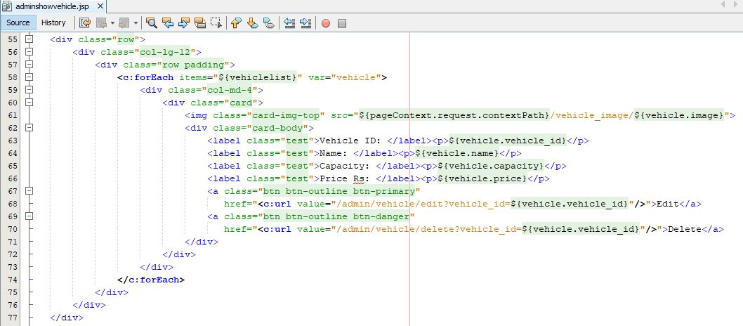

Screenshot: JSP file to display vehicle

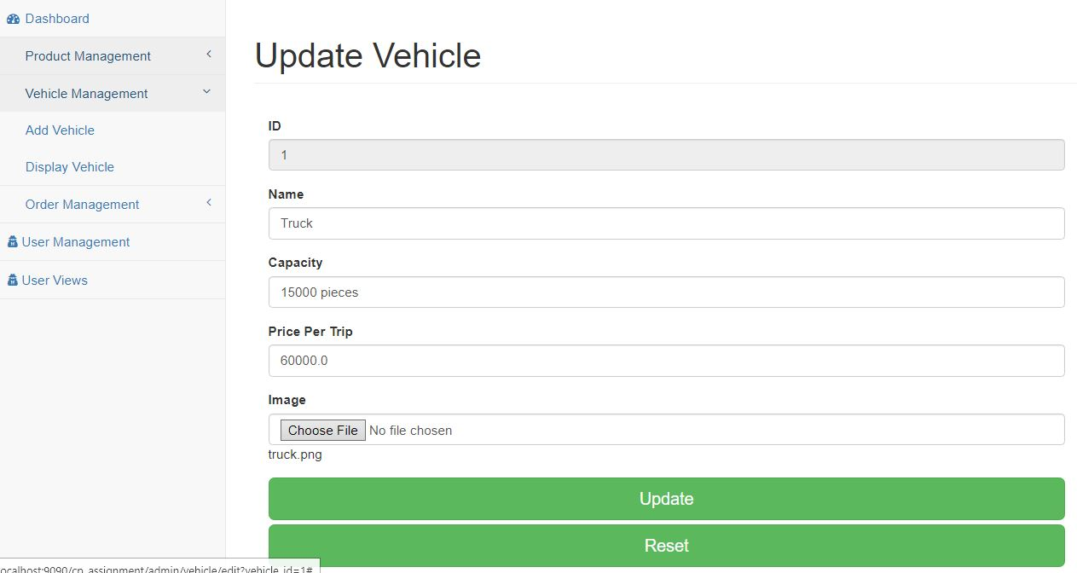

Screenshot: Form to update vehicle

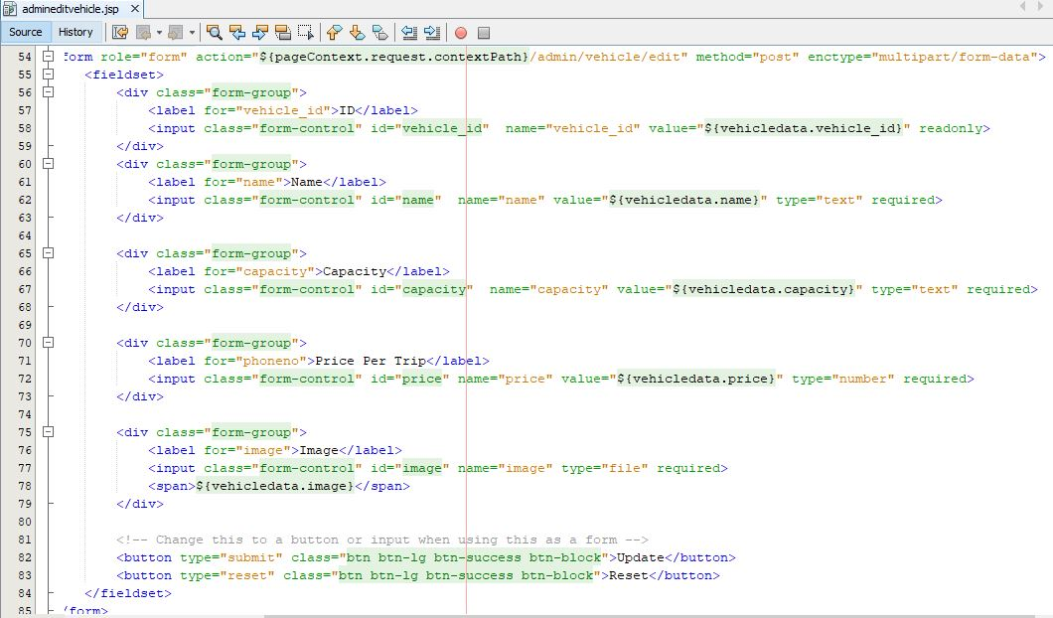

Screenshot: JSP file to edit vehicle

Admin User Manager

Controller to manage user by admin

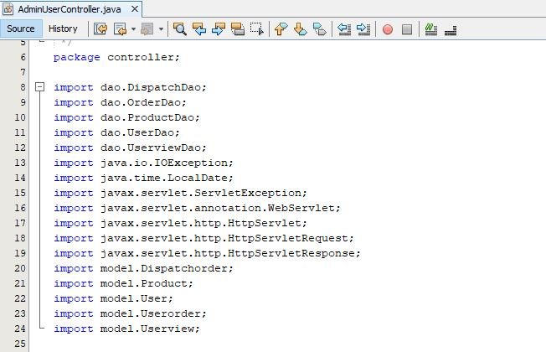

Screenshot: Required imported library for user controller

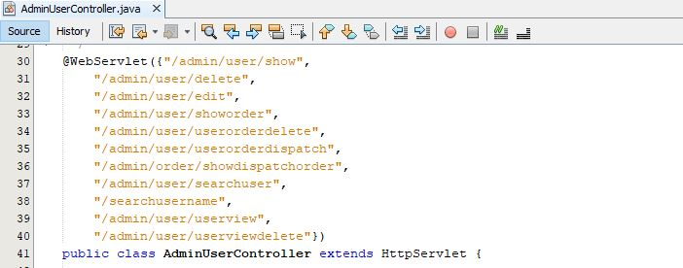

Screenshot: URL(Uniform Resources Locator) for admin user controller

User controller request in doGet and operation performed

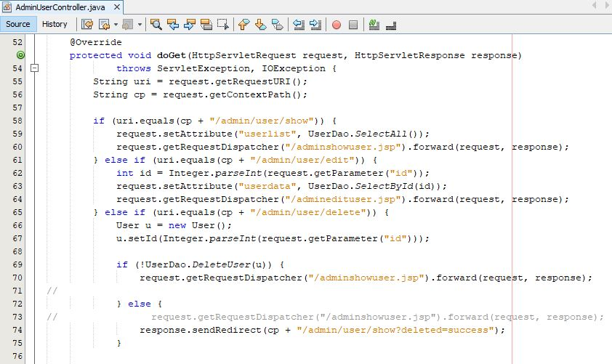

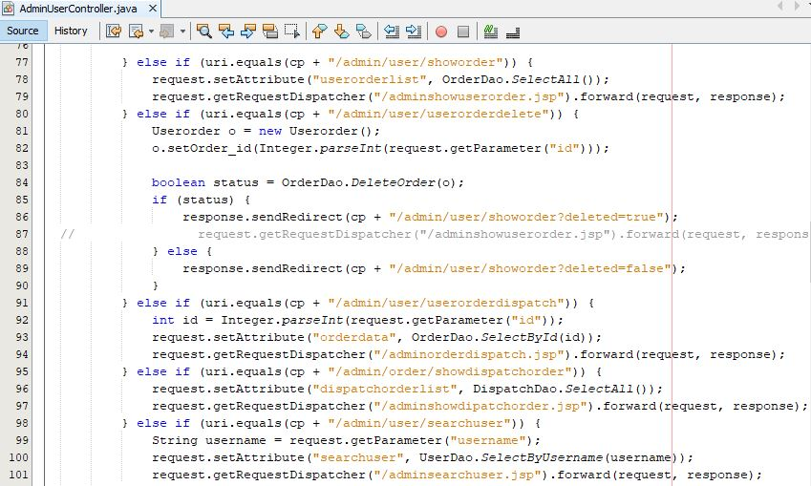

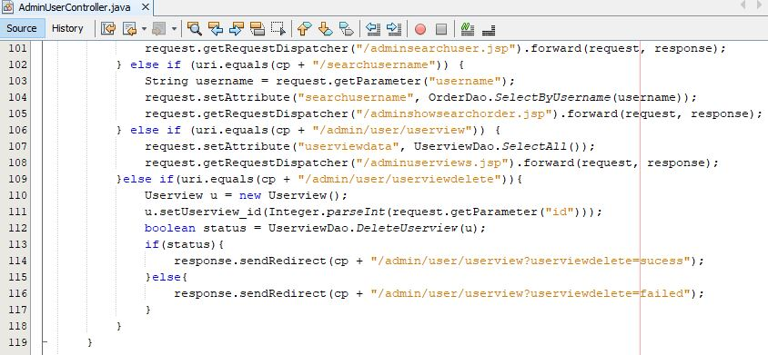

Form to manage user by admin

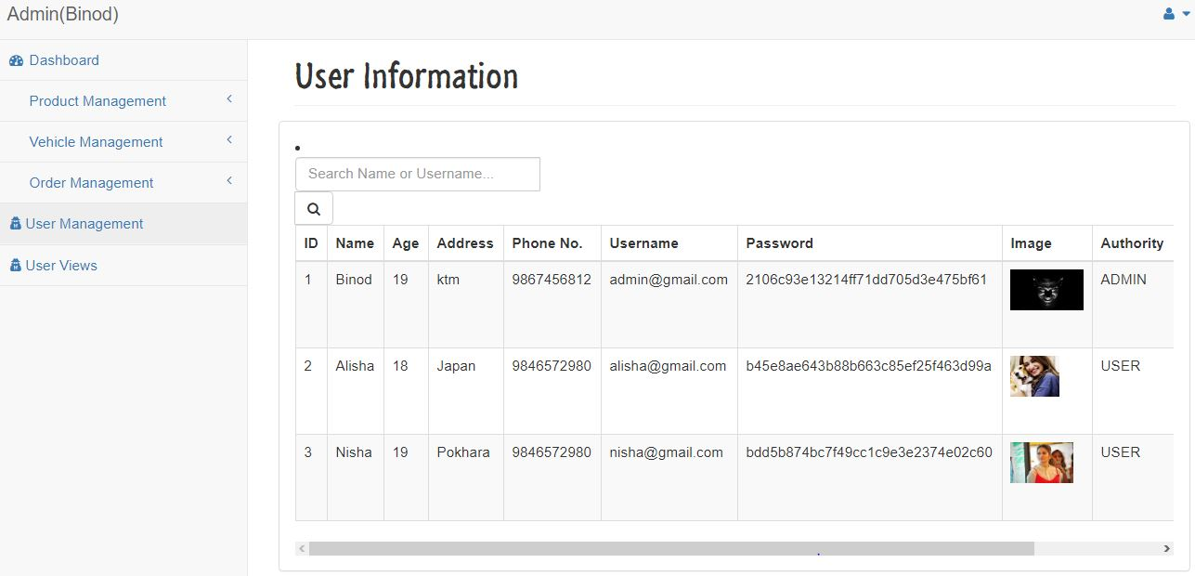

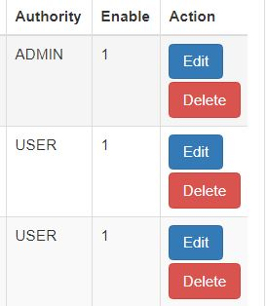

Screenshot: Form showing all user

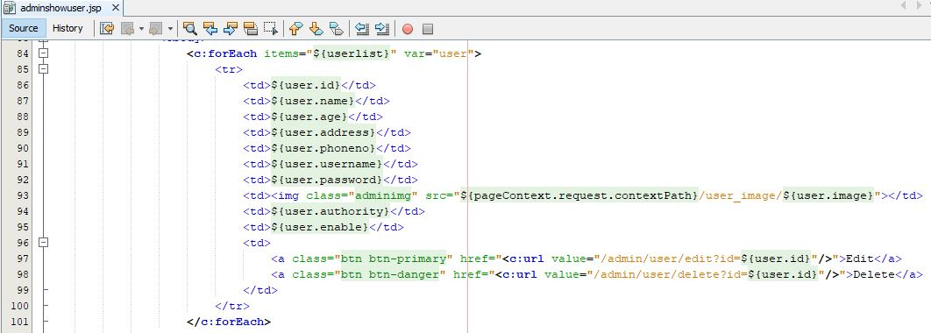

Screenshot: JSP file to display all user

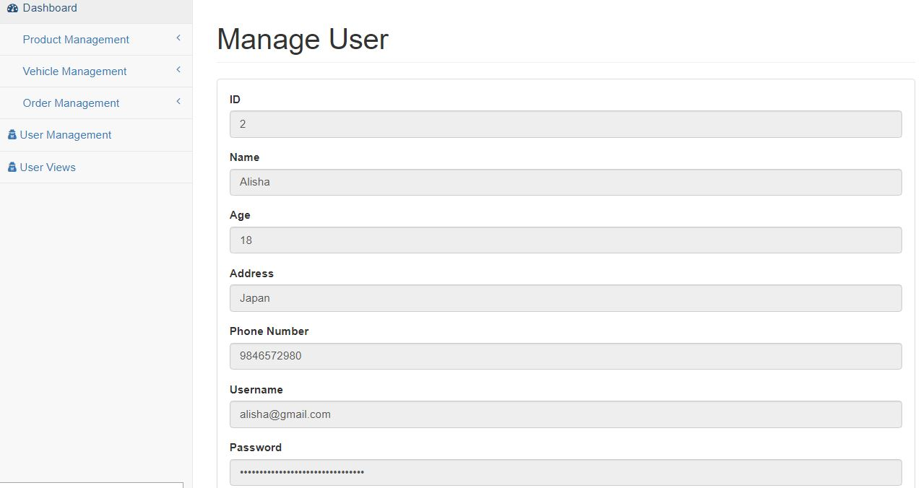

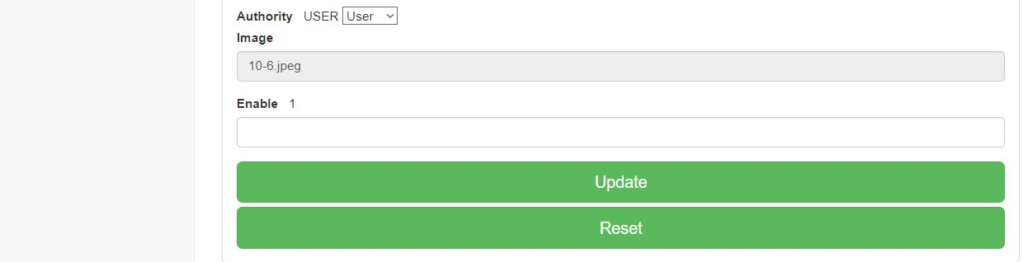

Screenshot: Form to update user by admin

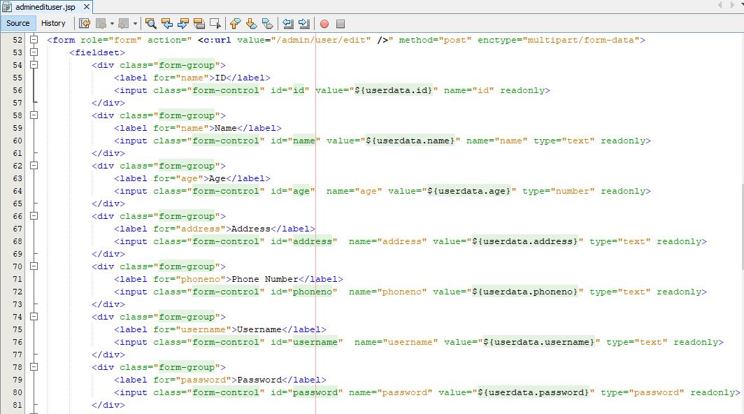

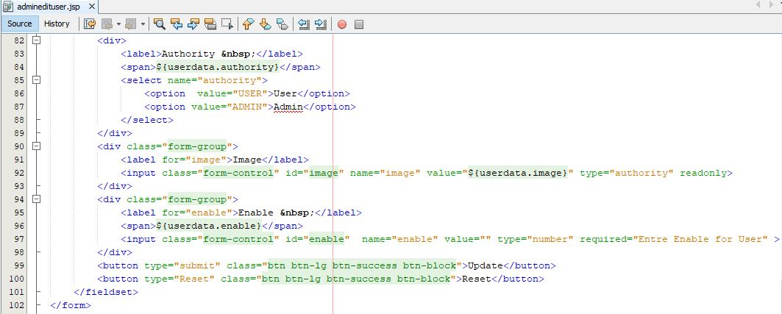

Screenshot: JSP file to update user by admin

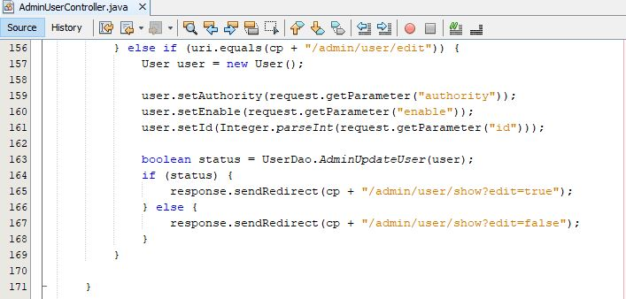

Screenshot: Controller to edit user by admin in doPost

Admin Dispatch Order

Model for dispatch order

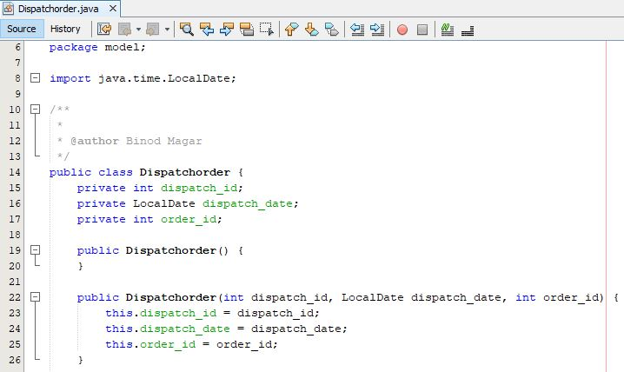

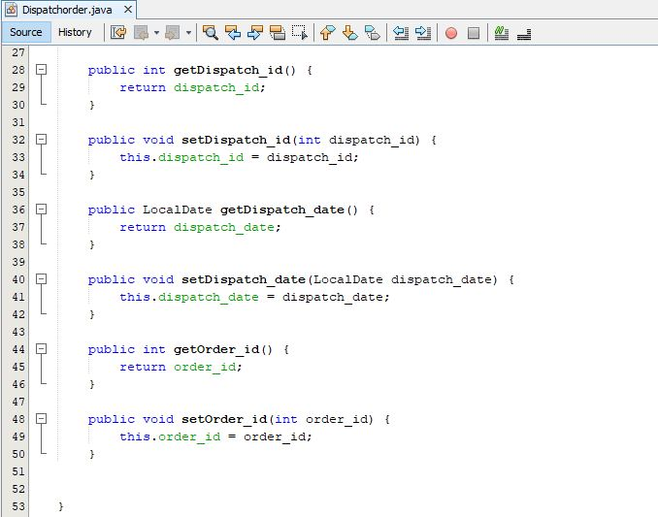

Screenshot: Model to dispatch order and required imported library

Dispatch order Dao(Data access object) for dispatch order

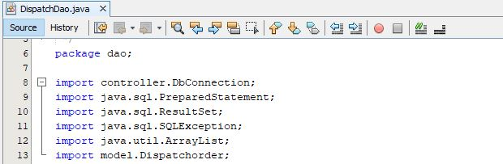

Screenshot: Required imported library for dispatch order Dao

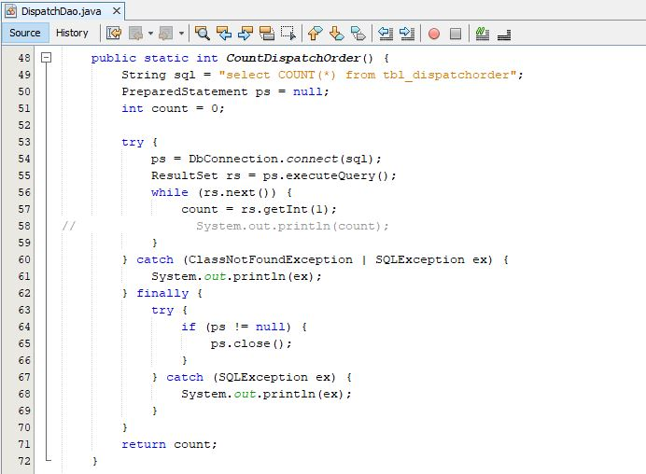

Screenshot: Dao to count all dispatch order

Form of the Dispatch order

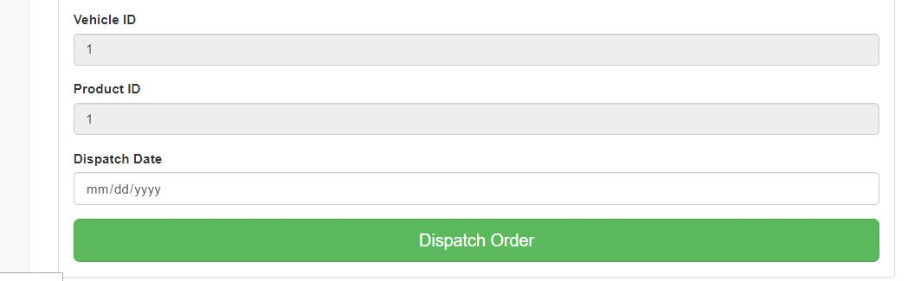

Screenshot: Form to dispatch the order

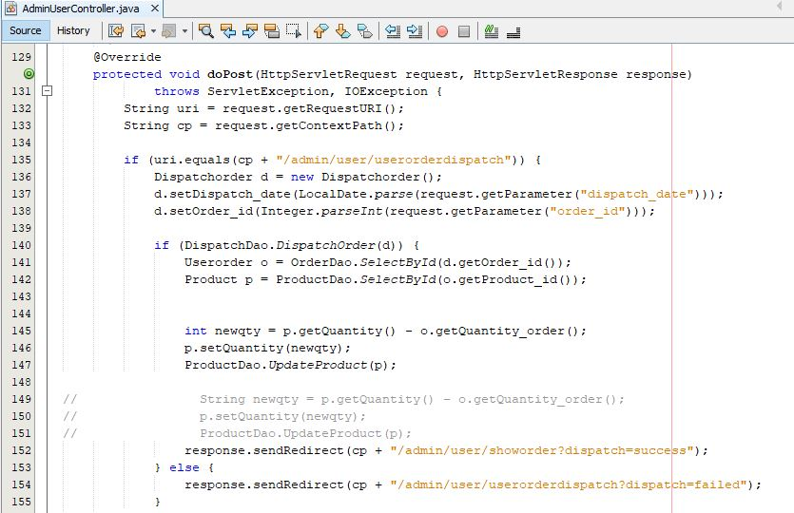

Screenshot: Controller for user order dispatch order

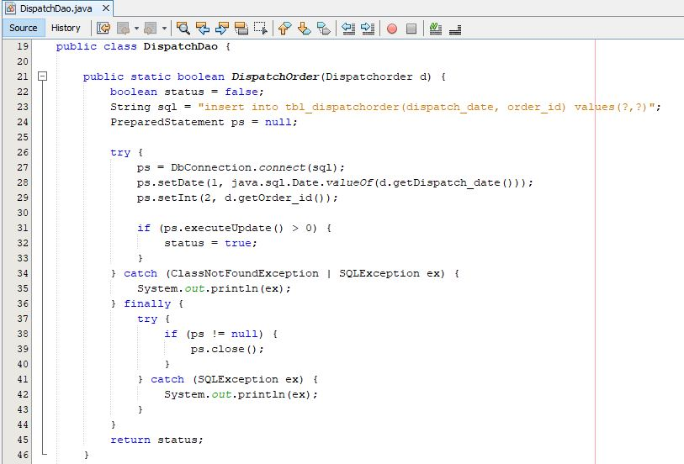

Screenshot: Dispatch Dao to insert data of dispatch order in the database

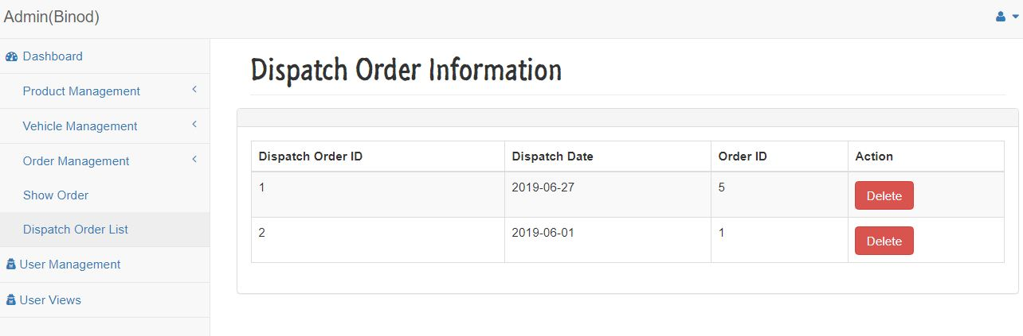

Screenshot: List of all dispatch order

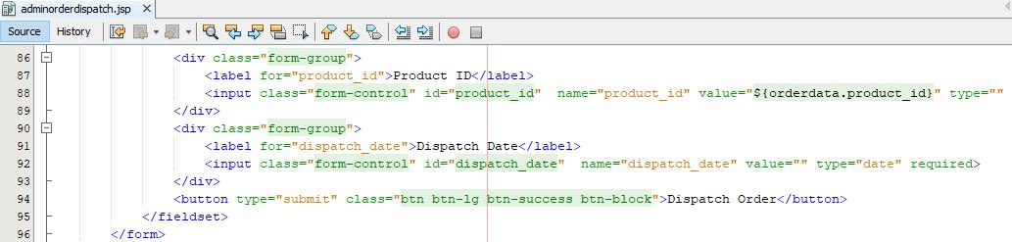

Screenshot: JSP(Java Server Page) to show all dispatch order

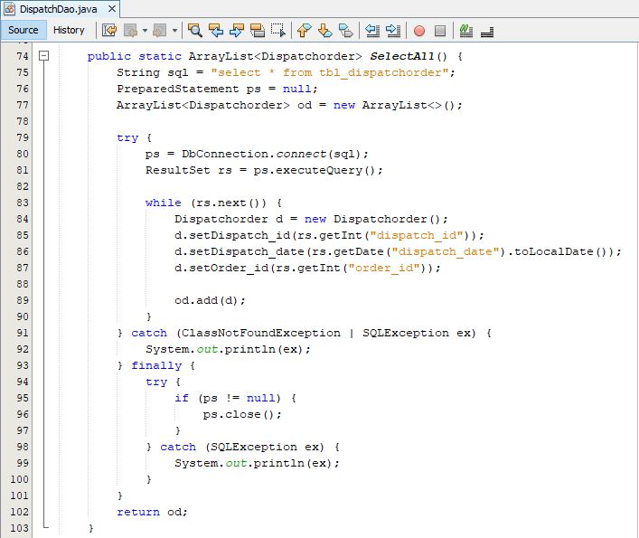

Screenshot: Dispatch Dao to select all dispatch order in ArrayList

Index page

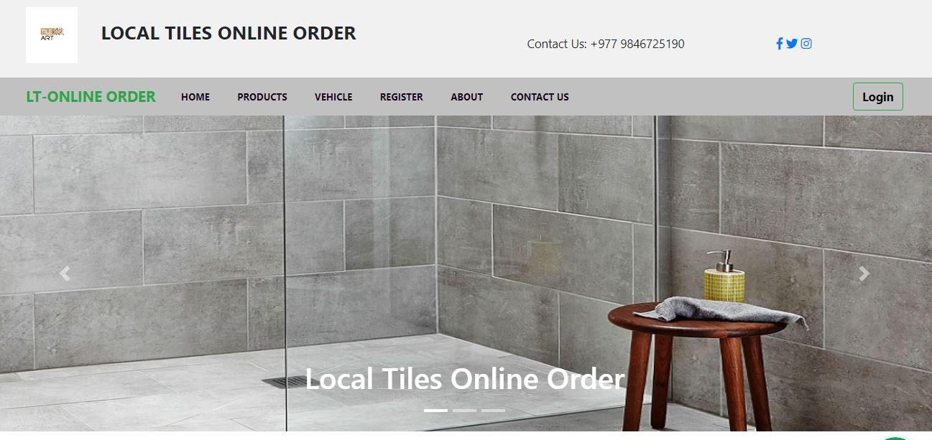

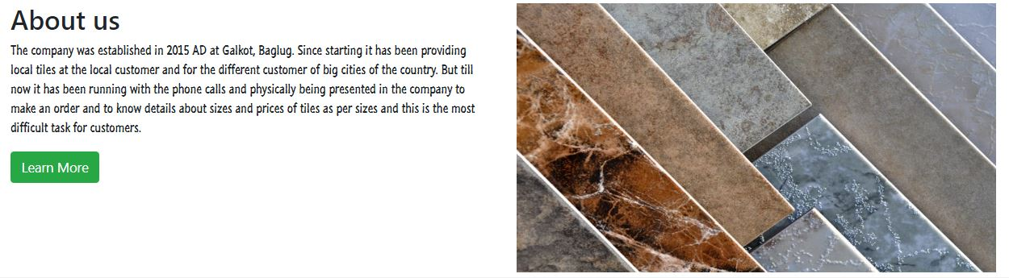

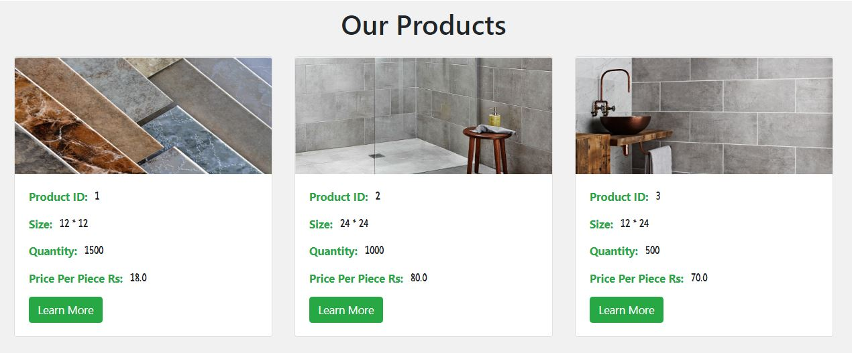

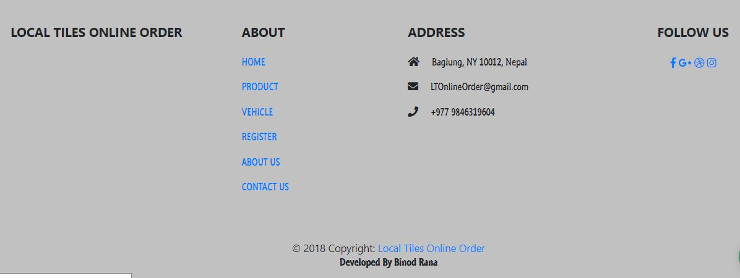

Screenshot: Home page

Controller for index page

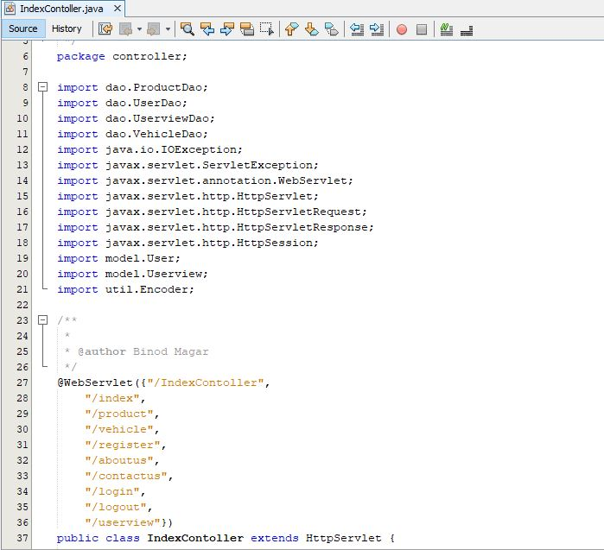

Screenshot: Required imported library and URL(Uniform Resources Locator)

Index controller doGet request and operation performed

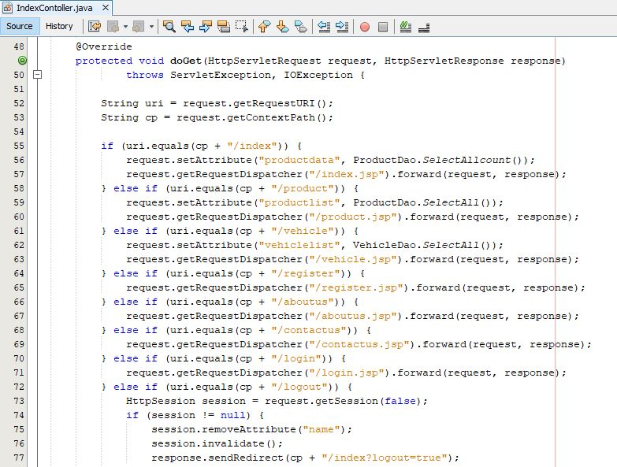

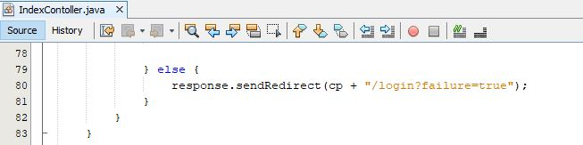

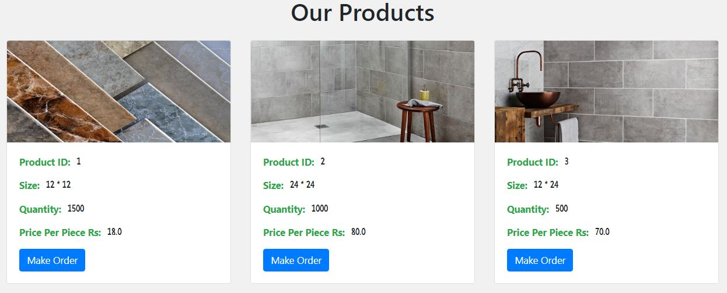

Screenshot: Our product pages

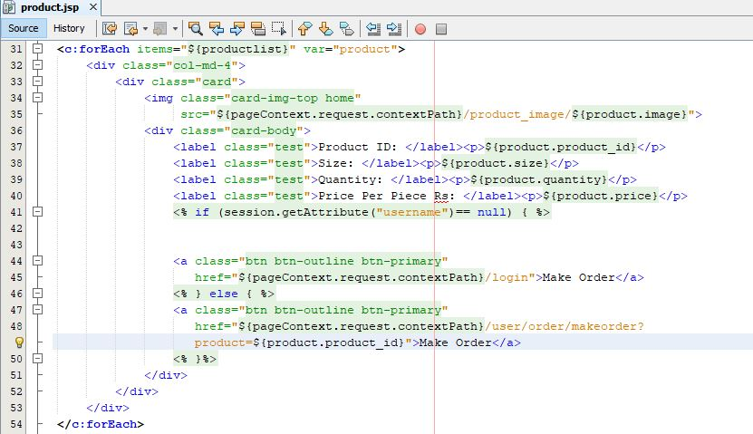

Screenshot: JSP file of our product page



Screenshot: ProductDao to select all product in ArrayList

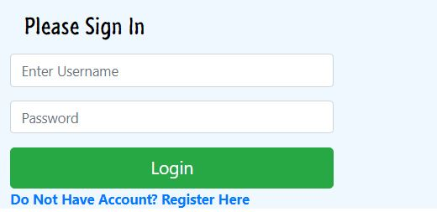

Screenshot: Login form

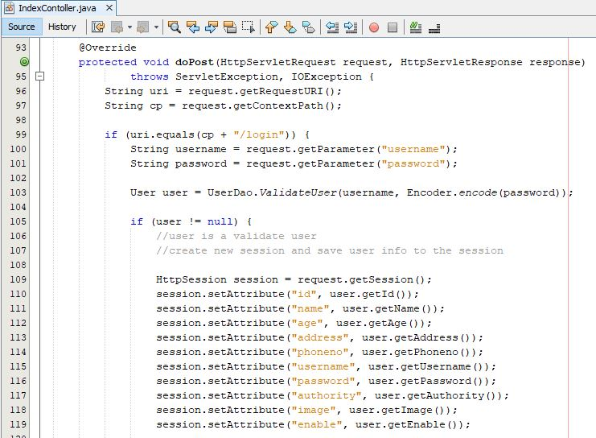

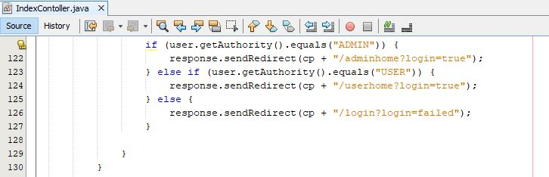

Screenshot: Controller for login

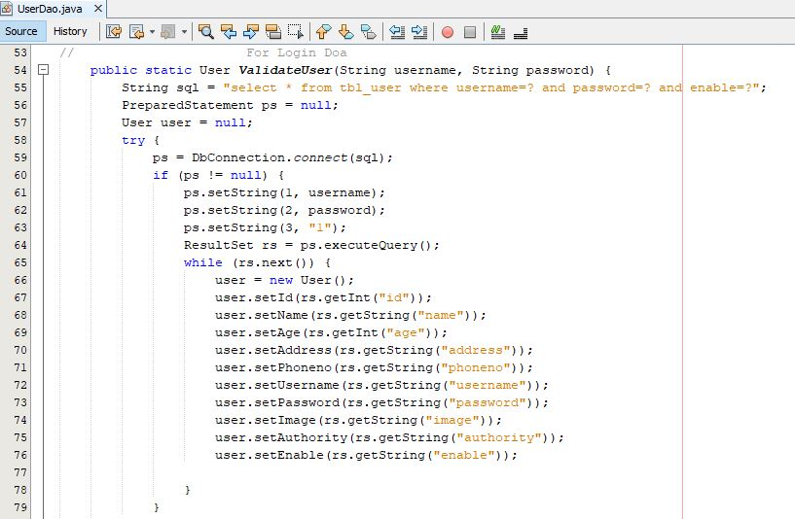

Screenshot: User dao to validate user

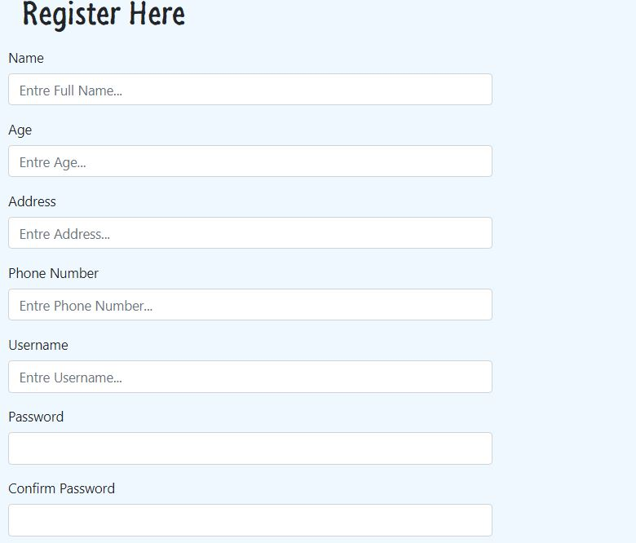

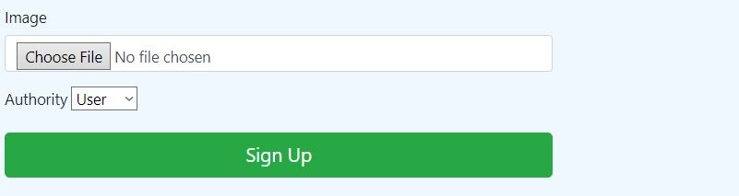

Screenshot: Register form

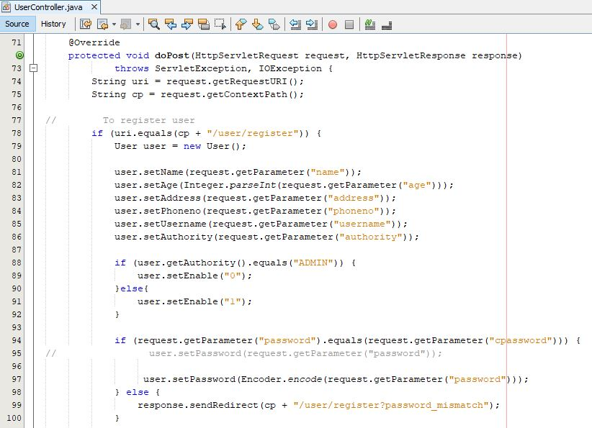

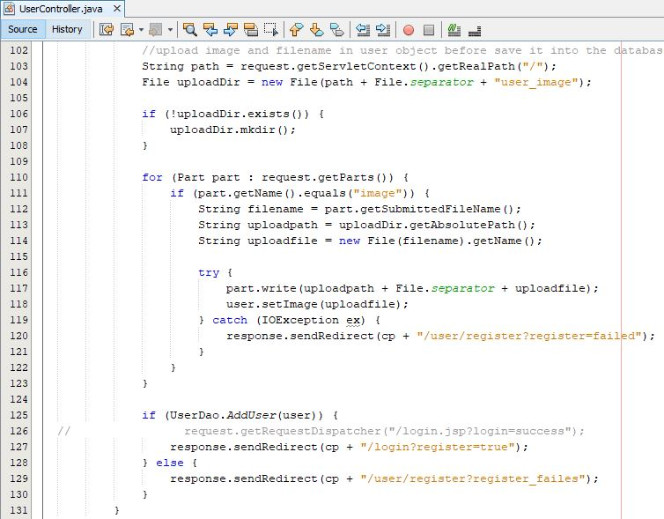

Screenshot: User controller for register user

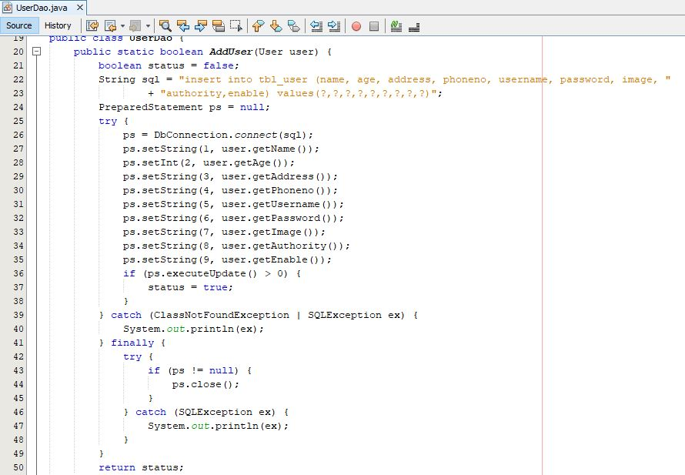

Screenshot: User Dao to insert data into database

Model for User

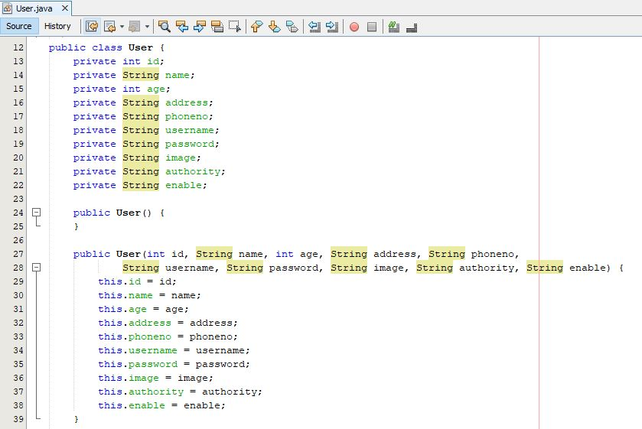

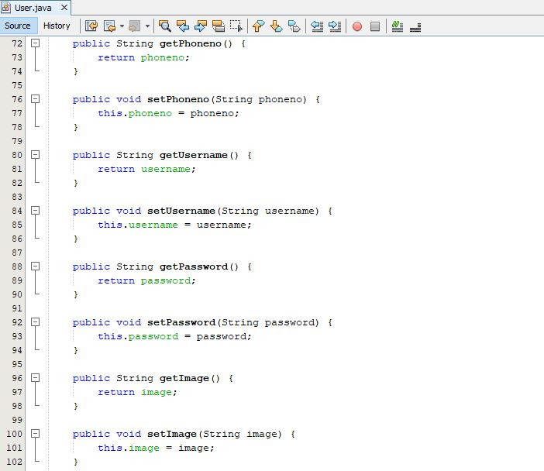

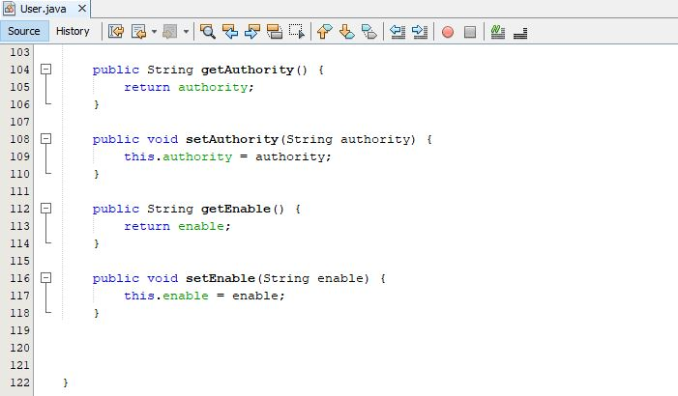

Controller for User profile

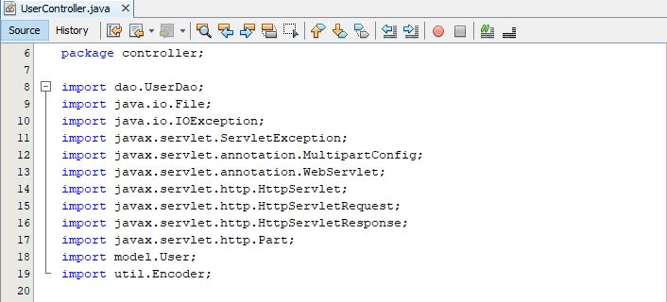

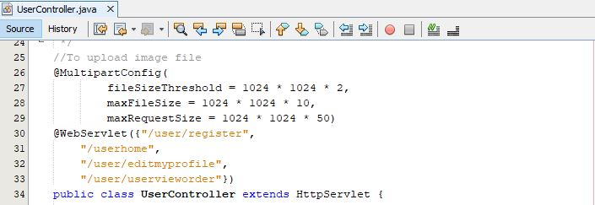

Screenshot: Imported library and URL pattern for user profile

User controller doGet request and operation performed

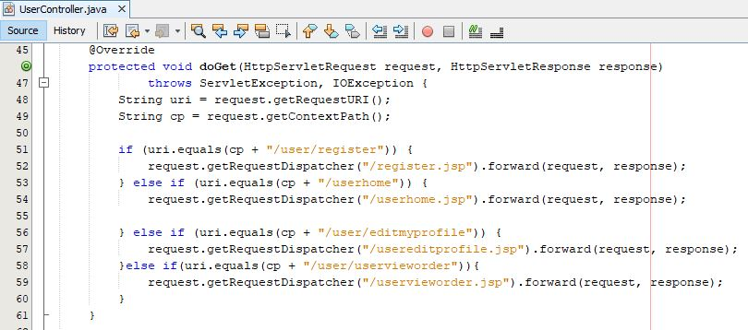

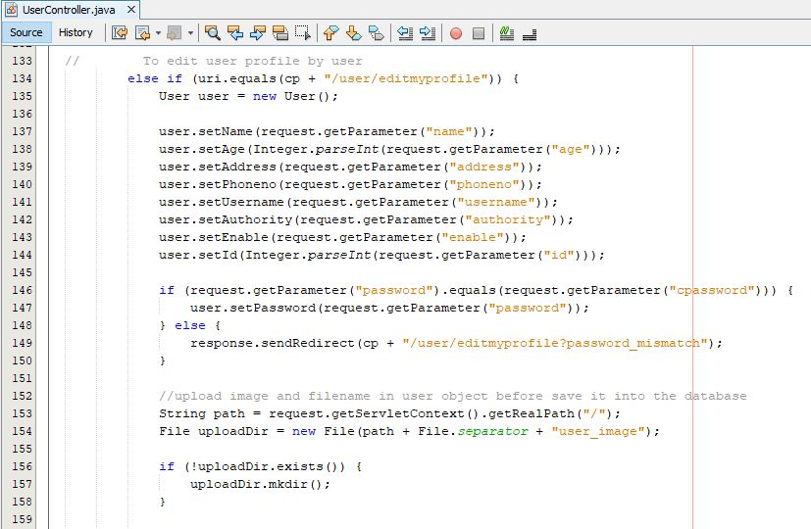

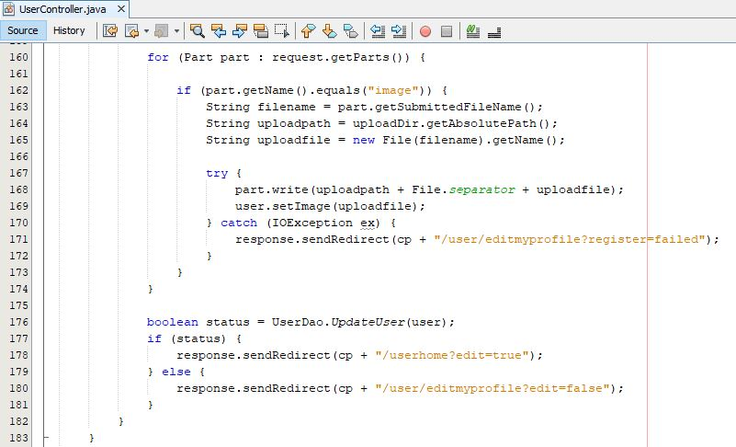

Screenshot: Controller for user edit profile

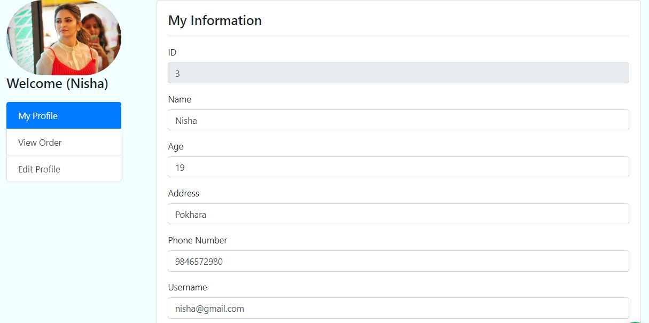

Screenshot: User profile

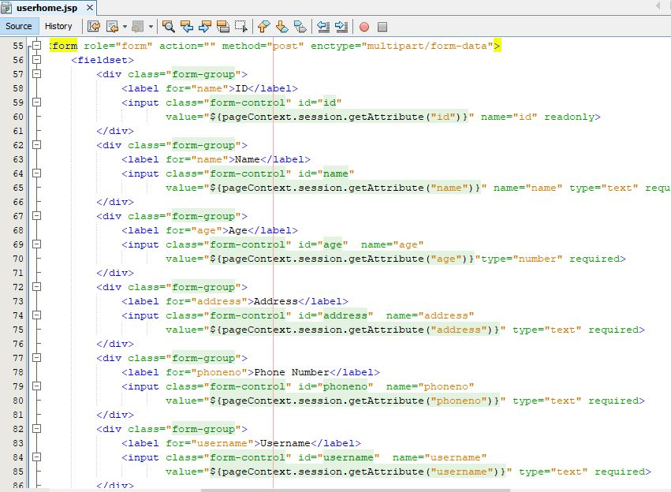

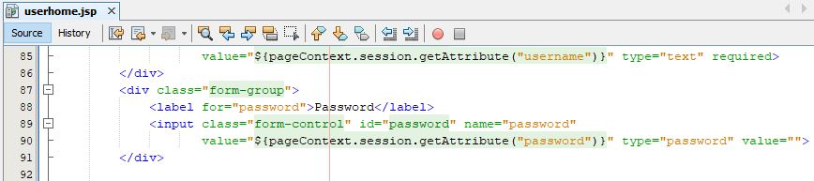

Screenshot: JSP file for user profile

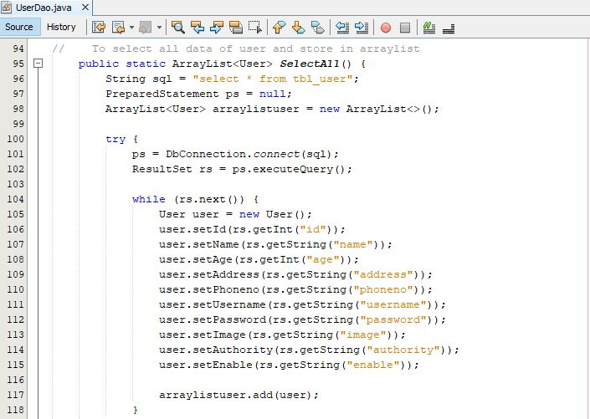

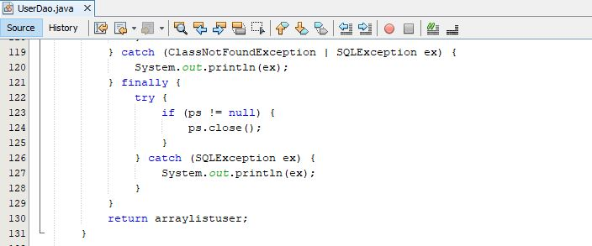

Screenshot: User Dao for user show profile

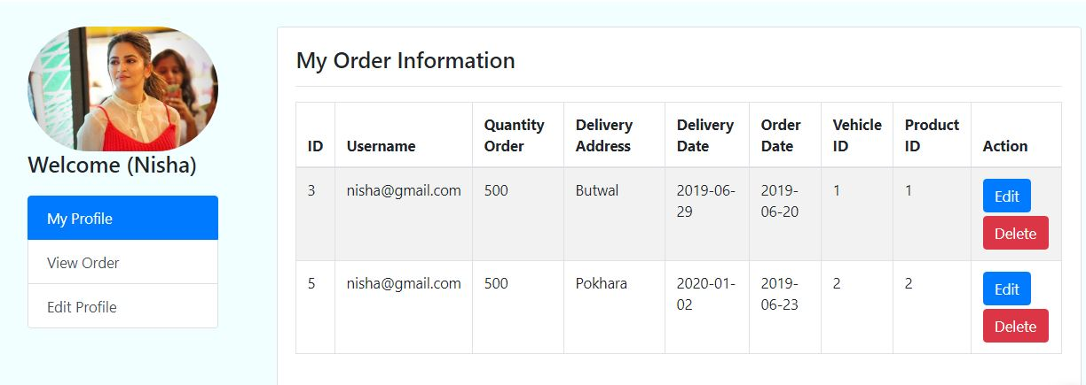

Screenshot: User show order

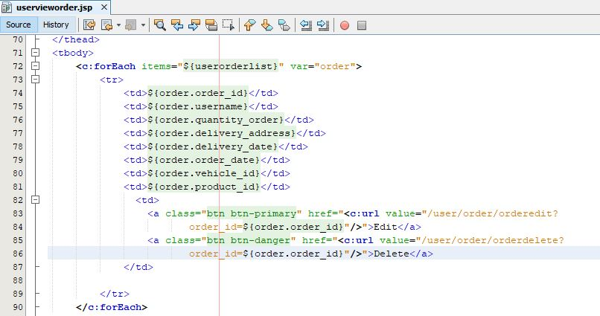

Screenshot: JSP file to show order

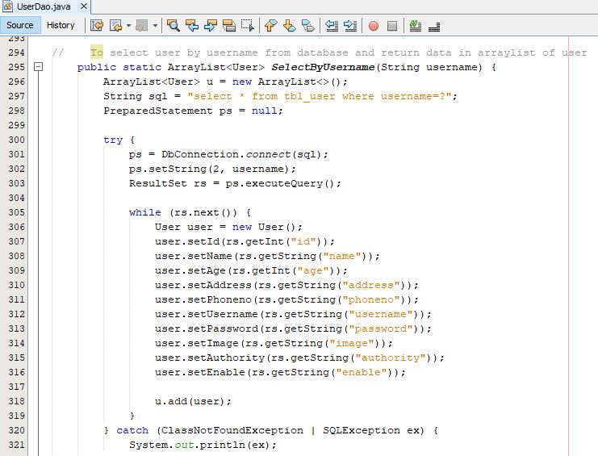

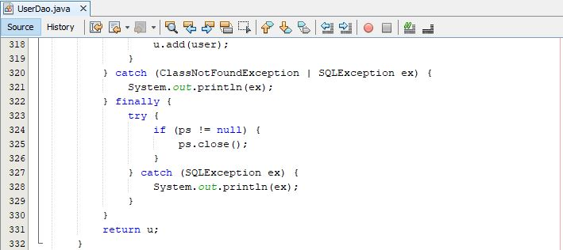

Screenshot: User dao to display order

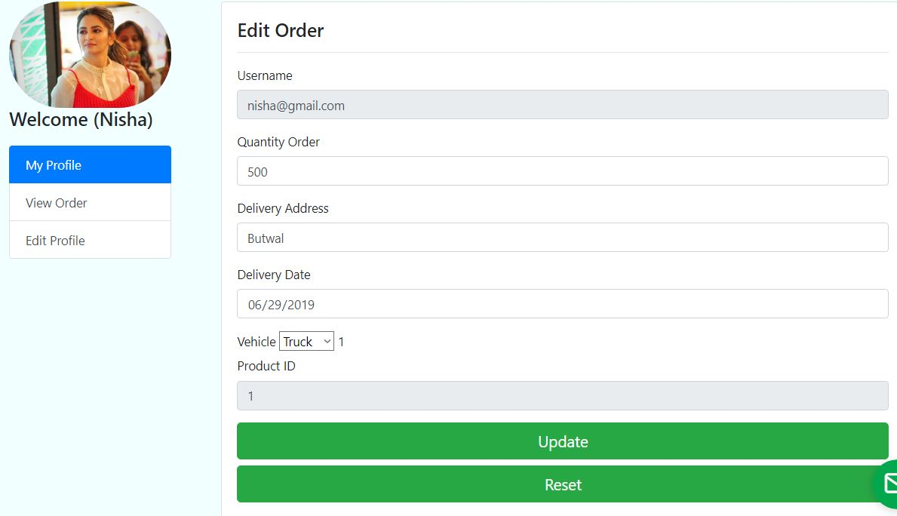Screenshot: User order edit form

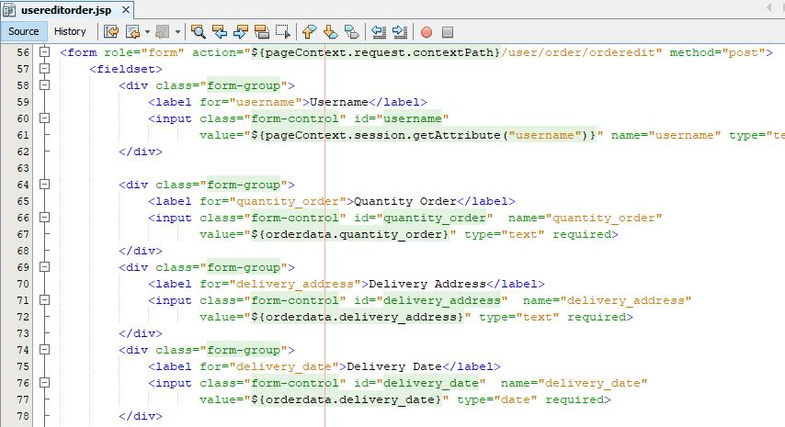

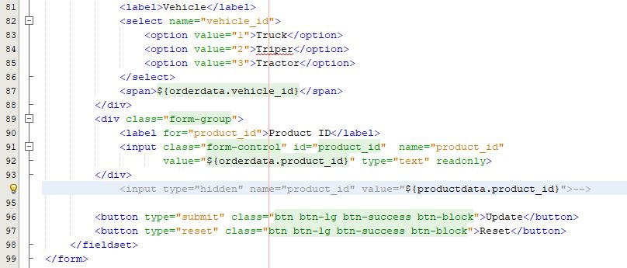

Screenshot: JSP file of user edit form

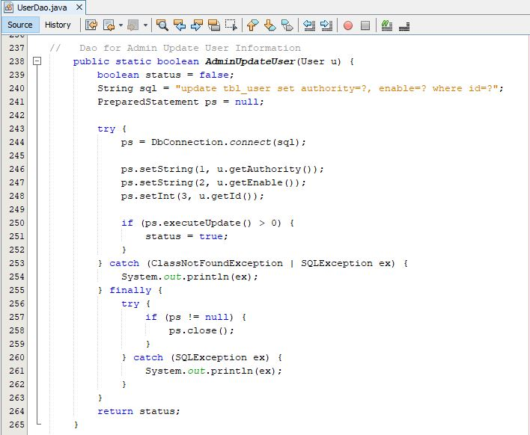

Screenshot: User dao to update

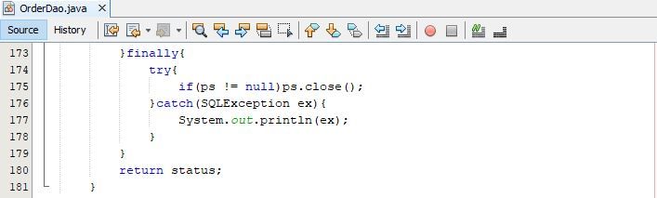

Screenshot: User order edit

# Chapter-5: Testing

## 5.1 Introduction

This is the fourth phase of Structured System Analysis and Design Methodology(SSADM). In this phase, codes or system are evaluated against the user requirement to make sure that if it meets requirements that were gathered. Here, it is also possible to find number errors and those errors are tried to be solved within the software program.

There are two types of testing:

1. White Box Testing:

* In this testing internal code or structure is known to the tester and test how the system performed based on the code.

1. Black Box Testing:

* In the black box, system functionality is verified and a complete test suite is required to execute in this type of testing

For my project I have chosen to the performed black box and JUnit testing:

## Black Box Testing

Test 1: Registration Testing Test Planned Date: 27-06-2019

Test Priority (High/Medium/Low): High Test Executed By Binod Rana

Test Completion Date: 27-06-2019

Test Title: User Registration testing

Pre-condition: New user can register details

Dependencies: Once registration details are entered by the user, to enter the system.

|  |  |  |  |  |  |
| --- | --- | --- | --- | --- | --- |
| Test No | Test Cases | Test Date | Excepted Result | Actual Result | Outcomes |
| i. | Check for empty fields | 27-06-2019 | User should be given an error message of empty fields. | Errors message is displayed to the user | Pass |
| ii. | Provide invalid data | 27-06-2019 | A user should not be registered and the message should be displayed | A user was not registered | Pass |
| iii. | Entered valid details | 27-06-2019 | A new user should be registered | A new user is registered | Pass |

Post Condition: Both admin and user can login

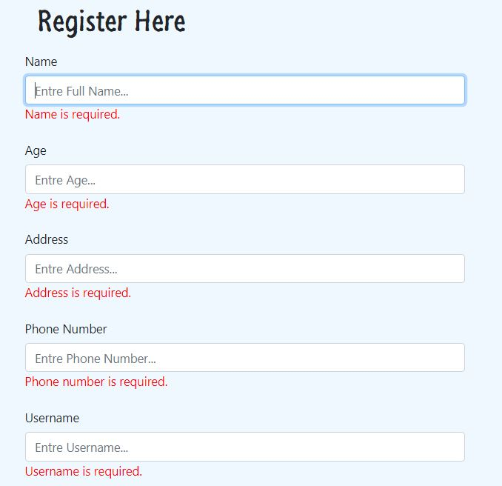

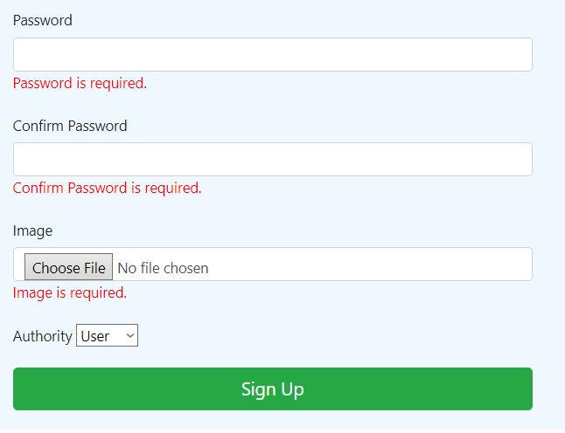

Test 2: Login Testing

Test title: User and Admin login testing Test Planned Date: 27-06-2019

Test Priority (High/Medium/Low): High Test Executed By Binod Rana

Test Completion Date: 27-06-2019

Pre-condition: Both admin and user enter login details

Dependencies: For login both admin and the user enter login details

|  |  |  |  |  |  |
| --- | --- | --- | --- | --- | --- |
| Test No | Test Scenarios | Test Date | Excepted Result | Actual Result | Outcomes |
| i. | Check the data entered | 27-06-2019 | Entered data need to be verified | Data was verified | Pass |
| ii. | Entered wrong data | 27-06-2019 | Error message to the user should be displayed | Error message displayed | Pass |
| iii. | Provide empty field | 27-06-2019 | An empty field error message should be displayed | Empty field error message displayed | Pass |
| iv. | Check logged in data if it is a user or admin | 27-06-2019 | If admin then redirect to admin home otherwise to the user home | Admin and user are redirected to their own home page as per data entered | Pass |

Post Condition: Error message during login displayed

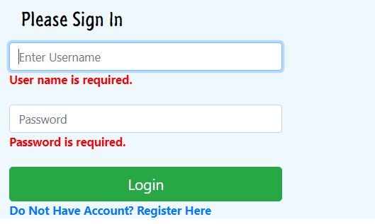

Test 3: Add Product Testing

Test title: Adding product testing by admin Test Planned Date: 27-06-2019

Test Priority (High/Medium/Low): High Test Executed By Binod Rana

Test Completion Date: 27-06-2019

Pre-condition: For adding new product admin need to login

Dependencies: To add new product details admin need to login to the system

|  |  |  |  |  |  |
| --- | --- | --- | --- | --- | --- |
| Test No | Test Cases | Test Date | Excepted Result | Actual Result | Outcomes |
| i. | Provide empty field during adding product | 27-06-2019 | The new product should not be added and should display errors message. | Error message displayed with the product not add. | Pass |
| ii. | Wrong input of data | 27-06-2019 | A message with the wrong input of data should be pop up | Message pop up with wrong input type | Pass |
| iii. | Provide valid product details | 27-06-2019 | The product should be added and displayed in both admin and user pages | Product added successfully and displayed in both admin and user page | Pass |

Post Condition: Error message of the empty field displayed

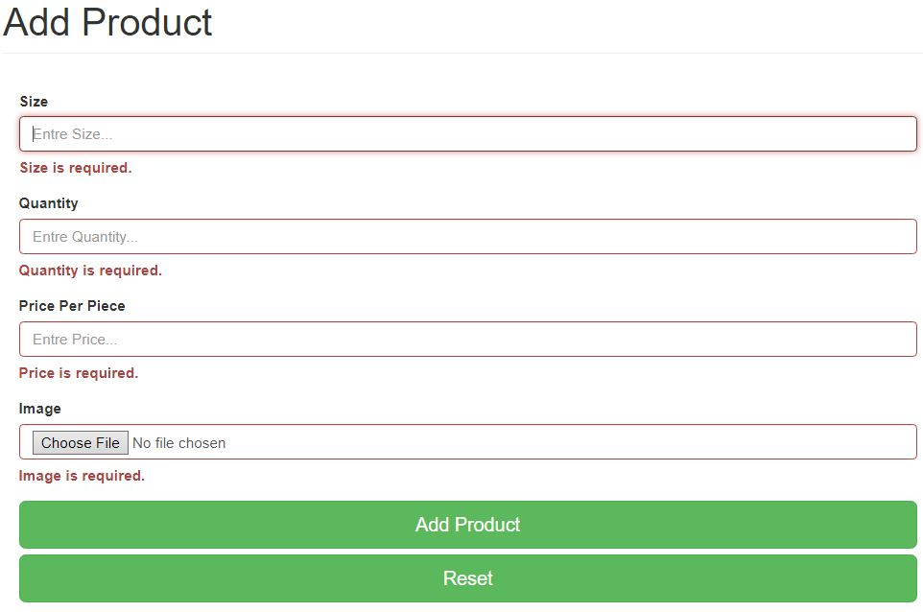

Test 4: Update product testing

Test title: Update product testing by admin Test Planned Date: 27-06-2019

Test Priority (High/Medium/Low): High Test Executed By Binod Rana

Test Completion Date: 27-06-2019

Pre-condition: For updating product admin need to login

Dependencies: To update product admin need to login to the system

|  |  |  |  |  |  |
| --- | --- | --- | --- | --- | --- |
| Test No | Test Scenario | Test Date | Excepted Result | Actual Result | Outcomes |
| i. | Select product by product_id | 27-06-2019 | Details of selected product_id should be displayed | Product details of selected product_id are shown | Pass |
| ii. | Check edited details for the update | 27-06-2019 | Details of the edited product should be checked | Edited details of product checked successfully | Pass |
| iii. | Update details of selected product_id | 27-06-2019 | Details of selected product_id should be updated | Product update successfully and displayed in both admin and user page | Pass |

Post Condition: Selected product to update get displayed with details

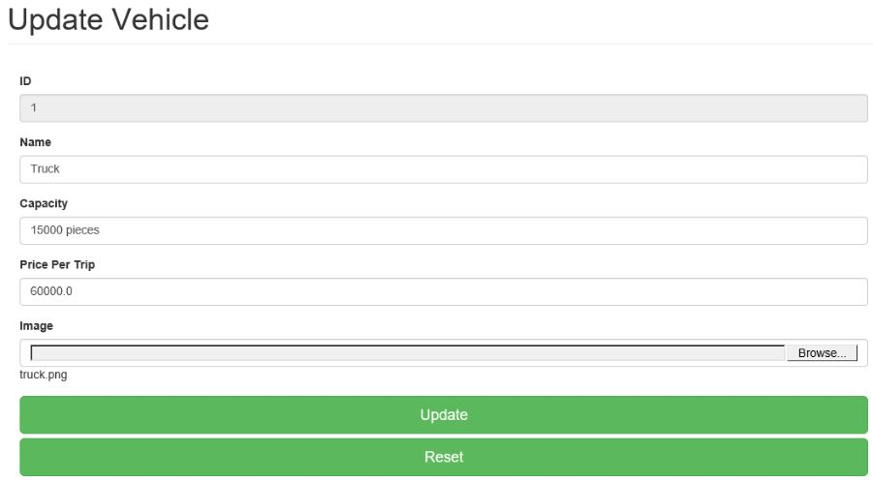

Test 5: Delete product testing

Test title: Delete product testing by admin Test Planned Date: 27-06-2019

Test Priority (High/Medium/Low): High Test Executed By Binod Rana

Test Completion Date: 27-06-2019

Pre-condition: Admin needs to login and product id need to available

Dependencies: To delete the product admin need to login to the system

|  |  |  |  |  |  |
| --- | --- | --- | --- | --- | --- |
| Test No | Test Scenarios | Test Date | Excepted Result | Actual Result | Outcomes |
| i. | Select product_id for delete | 27-06-2019 | Selected product_id should be retrieved | Product_id retrieved for delete | Pass |
| ii. | Delete selected product_id | 27-06-2019 | Selected product_id should be delete | Selected product_id deleted from both admin and user page | Pass |

Post Condition: Selected product deleted from both admin and frontend page

Test 6: User make order testing

Test title: User make order testing Test Planned Date: 27-06-2019

Test Priority (High/Medium/Low): High Test Executed By Binod Rana

Test Completion Date: 27-06-2019

Pre-condition: Login user can make an order of available product

Dependencies: To order product user need to login to the system

|  |  |  |  |  |  |
| --- | --- | --- | --- | --- | --- |
| Test No | Test Cases | Test Date | Excepted Result | Actual Result | Outcomes |
| i. | Select product to make an order | 27-06-2019 | Selected product details should be retrieved | Product detailed retrieved | Pass |
| ii. | Provide wrong input details | 27-06-2019 | Errors message should be displayed | A message displayed of wrong input | Pass |
| iii. | Provide the right detail for order | 27-06-2019 | The order should be made | An order made and displayed in both admin and user page | Pass |

Post Condition: Selected product to make order get displayed with details and displayed error message of empty fields

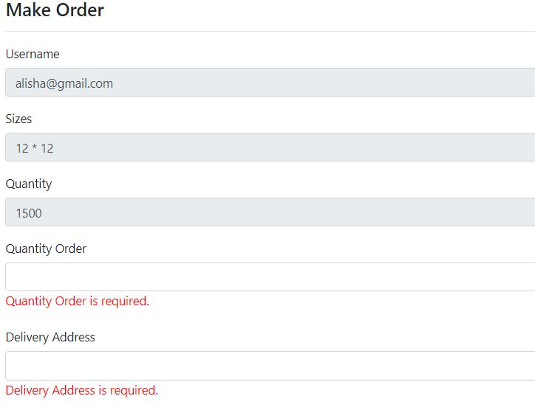

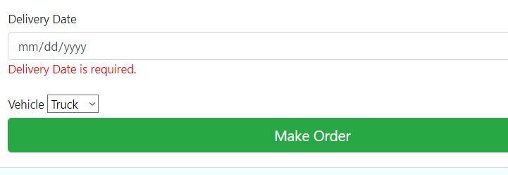

Test 7: Dispatch order testing

Test title: Dispatch order testing Test Planned Date: 27-06-2019

Test Priority (High/Medium/Low): High Test Executed By Binod Rana

Test Completion Date: 27-06-2019

Pre-condition: Admin need to login to the system to dispatch the order

Dependencies: To dispatch order admin need to login to the system

|  |  |  |  |  |  |
| --- | --- | --- | --- | --- | --- |
| Test No | Test scenarios | Test Date | Excepted Result | Actual Result | Outcomes |
| i. | Select order_id for dispatch | 27-06-2019 | Selected order_id details should be retrieved | Details of selected order_id displayed | Pass |
| ii. | Dispatch selected order | 27-06-2019 | Selected order should be dispatch and product should be deducted | Order dispatch success and displayed and product deducted | Pass |

Post Condition: Order selected by admin to dispatch get selected

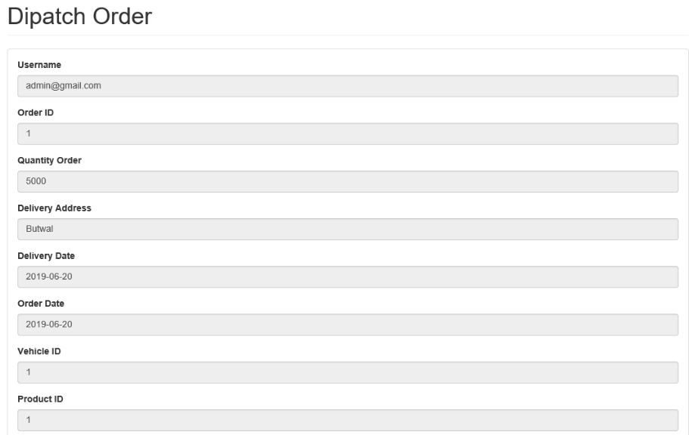

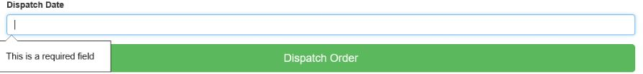

Test 8: Edit user testing

Test title: Edit user testing Test Planned Date: 27-06-2019

Test Priority (High/Medium/Low): High Test Executed By Binod Rana

Test Completion Date: 27-06-2019

Pre-condition: Admin need to login to the system to edit user

Dependencies: To edit user admin need to login to the system

|  |  |  |  |  |  |
| --- | --- | --- | --- | --- | --- |
| Test No | Test Scenarios | Test Date | Excepted Result | Actual Result | Outcomes |
| i. | Select user by user_id | 27-06-2019 | Details of the selected user by user_id should be retrieved | Details of the selected user by user_id retrieved | Pass |
| ii. | Provide empty field | 27-06-2019 | Errors message should be displayed | The error message of the empty field displayed. | Pass |
| iii. | Update user by valid details | 27-06-2019 | User should be updated | User updated successfully | Pass |

Post Condition: Selected user to edit by admin get displayed with details

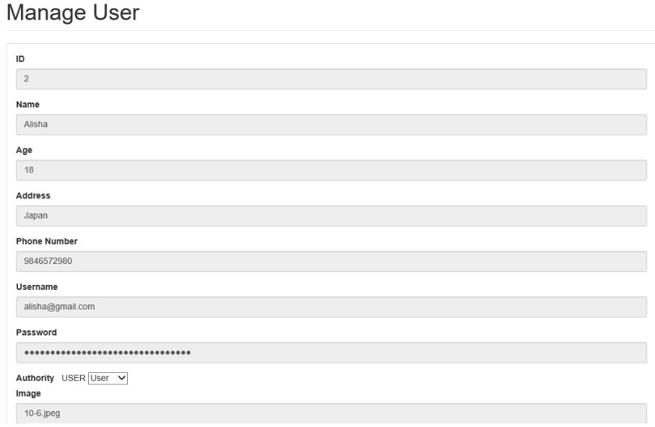

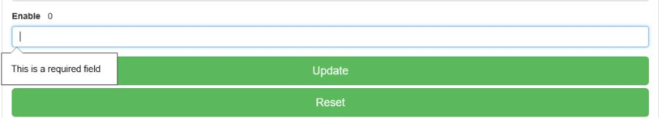

## Junit Testing

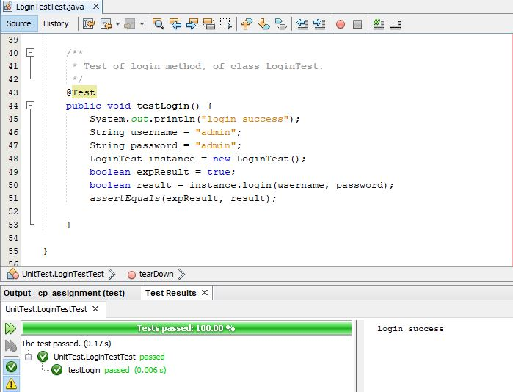

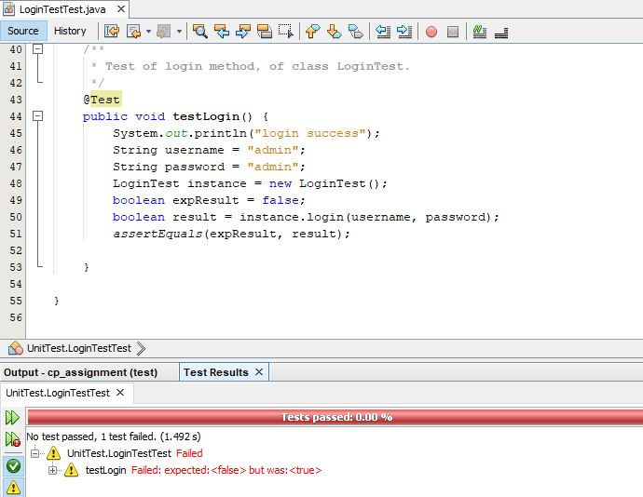

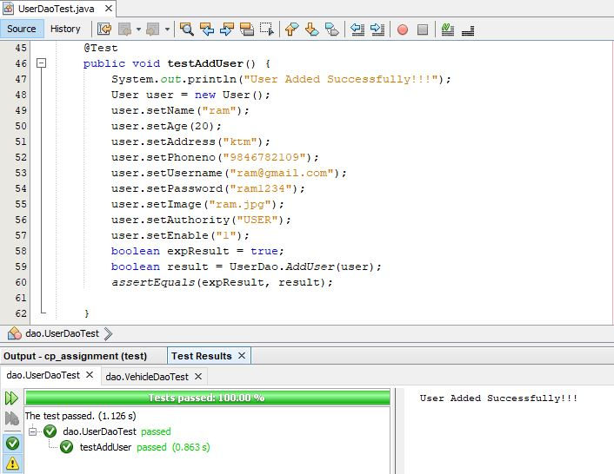

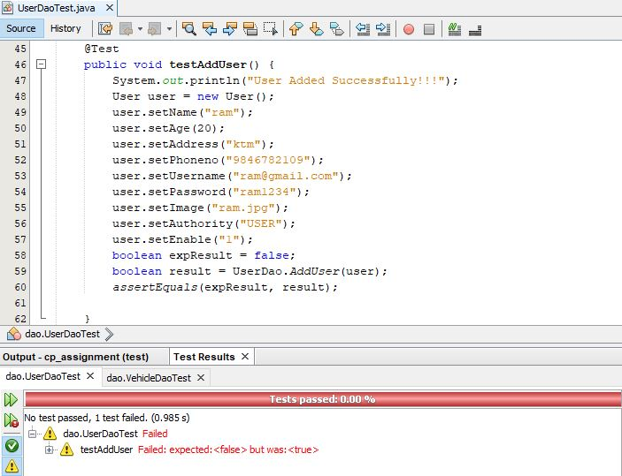



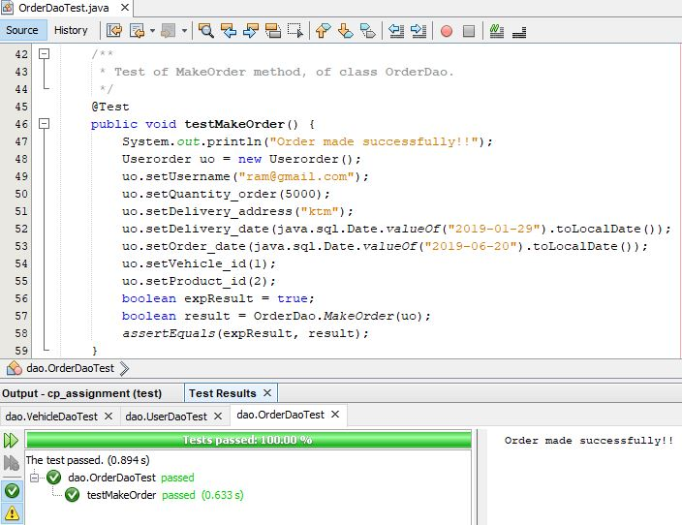

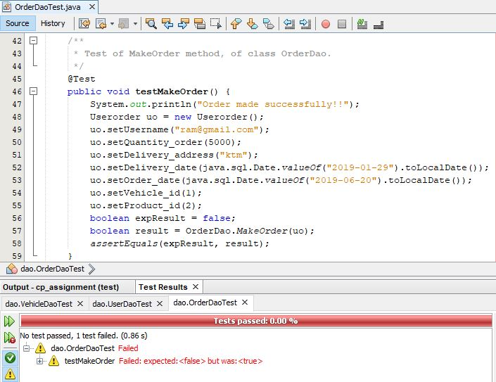



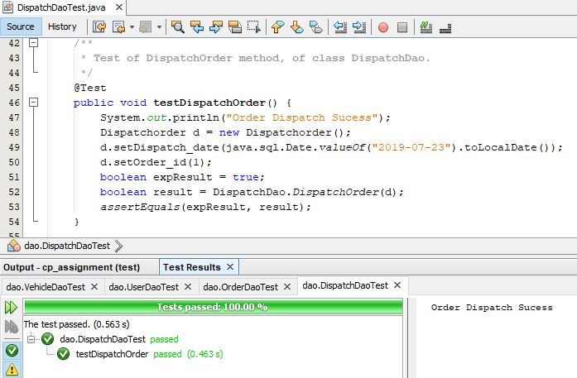

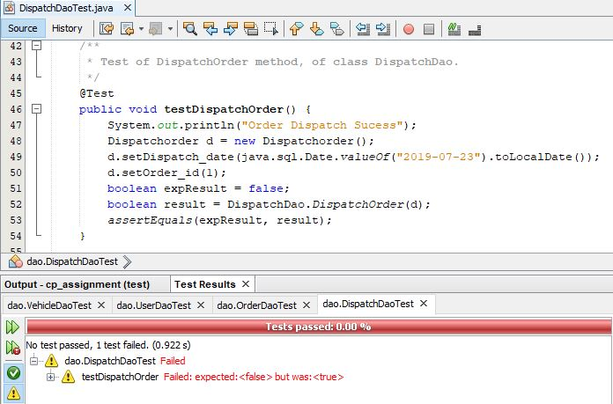



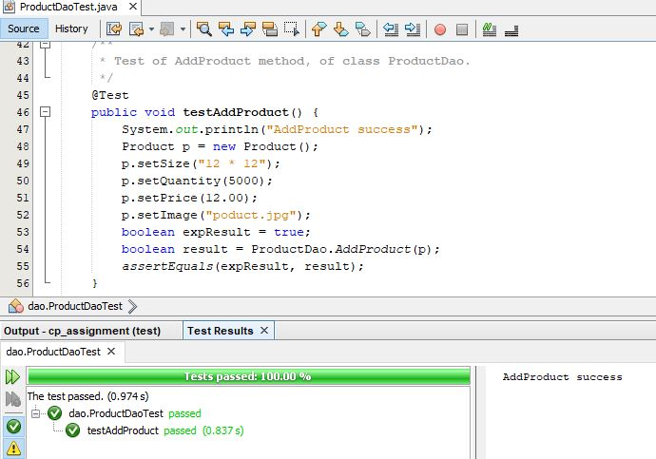

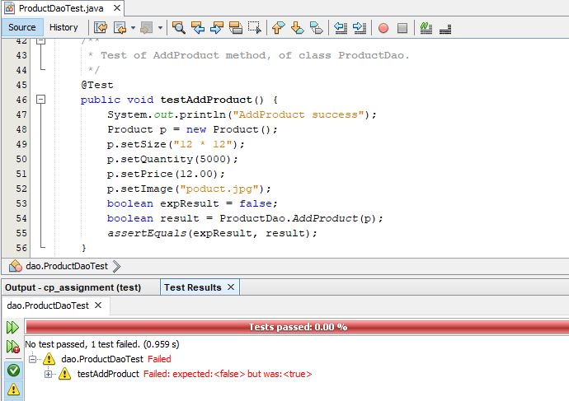



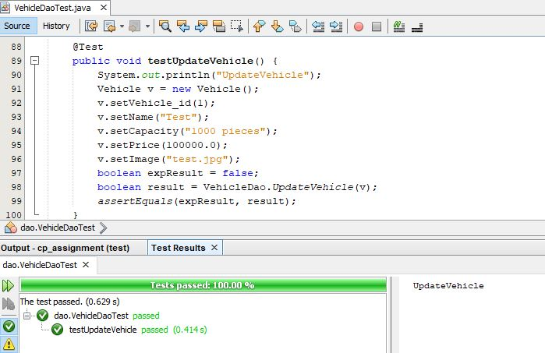

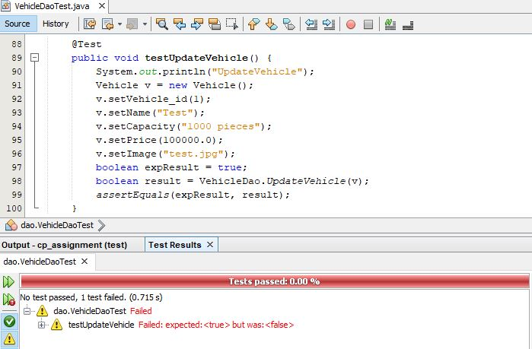



# Chapter-6: Other Project Issues

Developing any project start with different problems and issues. At the very beginning from proposal to requirement gathering, designing, implementation, testing, and final documentation many problems and issues arise. Tackling and handling those issues to move ahead and to complete the project was the aims.

## 6.1 Other project issues in the projects

Some of the issues and problems that I faced during completing projects are listed below:

* Doing a project in java:

First and greatest issues in my projects because I was trying to do my project in whole new programming language for me that is java.

Solutions: To solve this, I have studied online and got some help from teachers and my seniors.

* Limited time:

As there will be always a limited time to complete any projects but for me, this becomes more challenging because on one side I have to learn java which is new for me and whereas in another hand I have limited time to complete.

Solutions: Working hard and getting help from teachers and seniors help me to solve this.

* Junit testing

As Java was a new language for me, JUnit testing also new for me which becomes challenging issues for me to do JUnit test in my projects.

Solutions: Searching online and getting ideas from teachers help to solve this problem.

* Other issues

Different other issues like a relationship in the final class diagram, database design, drawing a static and dynamic diagram and other small issues came arising which constantly make me difficult to complete projects.

Solutions: To solve this, gets help from a teacher and read online.

## 6.2 Project Limitation

In the process of completion, many things need to be taken into consideration and many problems and issues arise. Due to this reason some of the project limitations arise which is given below:

* Online payment:

Customer cannot pay bills online of their order tiles because as it requires more technical integration knowledge, skills and needs to assure card data security.

* Integration with other apps

Customer cannot integrate their account with other social media apps like Facebook, Instagram, and Twitter because of lack of knowledge and inexperience.

* Order confirmation

As an online ordering website much online order will be made but to confirm those order whether it is fake or not admin need to manually call to provided phone number during making an order. It can’t be done because of the limited time constraint.

## 6.3 Future Work

In the process of completing any project problems, error, issues and other barrier arise that result to exclude other functionality and features which make the system more user-friendly, efficient and easy to use. So, some of those features and functionalities which will be included in future work are given below:

* Online payment:

Including online payment in the system make more easy and efficient to pay bills by the customer and as well as for the company.

* Order confirmation

Integrated this in the system will help the company staff to confirm the order of the customer easily and effectively.

* Multi-language system

Making the system multi-language will not only make user-friendly but also encourage and make the different language of people to use the system.

## 6.4 Risk Management

The way of managing conditional or unconditional risks that directly and indirectly affect developing system called risk management. During the development of project many new and old risks were found. some of them are listed below with their mitigation.

|  |  |  |
| --- | --- | --- |
| S.No | Risks | Mitigation ways |
| 1 | Data Breach | During the development to handle data breach strong rules and policy is implemented. |
| 2 | Hardware failure risk | To mitigate hardware failure data is back up in different ways. |
| 3 | Legal risk | Knowing there can be a legal risk, the system is developed considering rules and regulation of government. So as to tackle this risk |
| 4 | Functional and performance risk | Being limited time to complete there can be bugs in functionality and slowness in performance. So it has been tackled by doing both black box and JUnit testing |
| 5 | Schedule(time) risk | To manage this risk I have prioritized functionality and feature, followed SSADM method to complete the project in time. |

## 6.5 Configuration Management

Configuration management is the collection of activities, tools, processes, and methods. That can be used by project practitioners during the project life cycle to manage items.

As I completed my projects I have backup of my projects. I have a backup online in Github with the name of @Binodmagar. I have also backup my project to google drive.

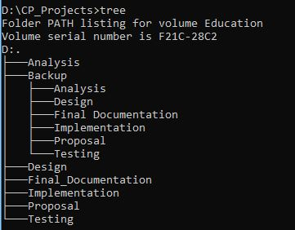

## 6.6 User Manual

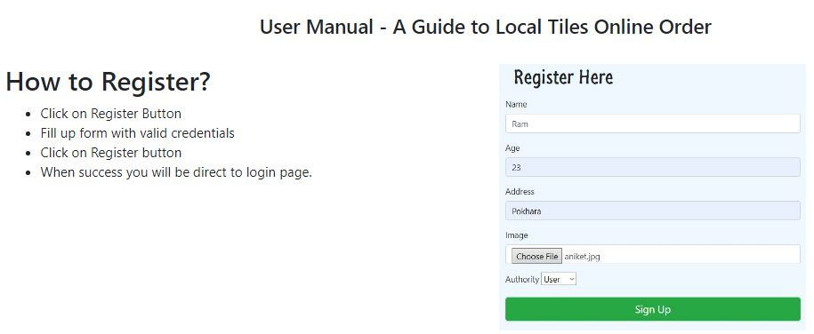

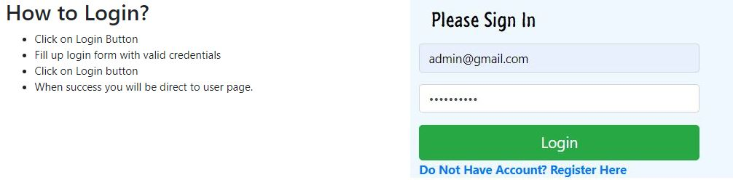

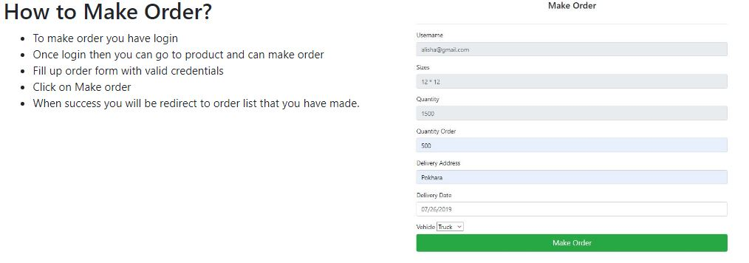

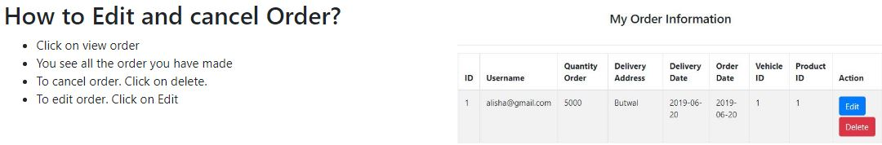

# Conclusion

The project starts once the proposal is accepted. Then as the software development methodology, Structured System Analysis and Design Method(SSADM) and its phases stated in the proposal. I started further development of the system.

The first phase was analysis where the requirement of the company was gathered, feasibility study of time, cost and resources are done to make sure that the developing system is feasible for the company, to show use-cases of users and admin use case diagram is done and architecture of the system is made.

After analysis, the design phase is done where how the system work and look is showed by making the structural, behavioral and user-interface design. Then in the implementation phase, I change the design phase into an actual product along with database build of the system. once implementation finished, testing of the developed system comes which is considered as an important phase in the SDM. In this phase testing like black and JUnit test is done of the developed system to ensure that there is no more bugs and problems in the system.

During completion of the system and all phases of software development methodology many small and big problems were faced, some of them are tackled by myself and some were by the help of teachers and online study. Overcoming all the problems and issues overall system is developed within a given time which meet the requirement that has been stated.

# Appendix

